TASK-AWARE OBJECT IDENTIFICATION FOR ASSISTIVE ROBOTICS USING PYNQ-Z2
A project report submitted in partial fulfilment
of the requirements for the degree of
Bachelor of Technology
in
Electronics and Computer Engineering
by
Shubh Gupta
23BLC1322
Aarav Sharma
23BLC1300
Ankush Kumar Jaiswal
23BLC1179
Under the guidance of
Prof. Jean Jenifer Nesam J


School of Electronics Engineering
Vellore Institute of Technology, Chennai
Vandalur - Kelambakkam Road
Chennai – 600127, India

October 2026


School of Electronics Engineering

Declaration
We hereby declare that the report titled Task-Aware Object Identification for Assistive Robotics using PYNQ-Z2 submitted by us to the School of Electronics Engineering, Vellore Institute of Technology, Chennai, in partial fulfilment of the requirements for the award of Bachelor of Technology in Electronics and Computer Engineering, is a bonafide record of the work carried out by us under the supervision of Prof. Jean Jenifer Nesam J.
We further declare that the work reported in this report has not been submitted and will not be submitted, either in part or in full, for the award of any other degree or diploma of this institute or of any other institute or University.

Name | Reg. No. | Signature of the Student
Shubh Gupta | 23BLC1322
Aarav Sharma | 23BLC1300
Ankush Kumar Jaiswal | 23BLC1179

Place: Chennai
Date: ․․․․․․․․․․․․․․․․․․

School of Electronics Engineering

Certificate
This is to certify that the project report titled Task-Aware Object Identification for Assistive Robotics using PYNQ-Z2 submitted by Shubh Gupta (23BLC1322), Aarav Sharma (23BLC1300) and Ankush Kumar Jaiswal (23BLC1179) to Vellore Institute of Technology, Chennai, in partial fulfilment of the requirement for the award of the degree of Bachelor of Technology in Electronics and Computer Engineering is a bonafide work carried out under my supervision. The project report fulfils the requirements as per the regulations of this University and, in my opinion, meets the necessary standards for submission. The contents of this report have not been submitted and will not be submitted either in part or in full, for the award of any other degree or diploma and the same is certified.
Supervisor | Head of the Department
Signature: ․․․․․․․․․․․․․․․․․․․․․․ | Signature: ․․․․․․․․․․․․․․․․․․․․․․
Name: Prof. Jean Jenifer Nesam J | Name: Dr. Vijayakumar P
Date: ․․․․․․․․․․․․․․․․․․․․․․ | Date: ․․․․․․․․․․․․․․․․․․․․․․
Examiner 1 | Examiner 2
Signature: ․․․․․․․․․․․․․․․․․․․․․․ | Signature: ․․․․․․․․․․․․․․․․․․․․․․
Name: ․․․․․․․․․․․․․․․․․․․․․․ | Name: ․․․․․․․․․․․․․․․․․․․․․․
Date: ․․․․․․․․․․․․․․․․․․․․․․ | Date: ․․․․․․․․․․․․․․․․․․․․․․

(Seal of the School)

Abstract
Object detectors tell a robot what is in a scene but not which object satisfies a user’s request. An assistive robot asked for “something to drink from” must choose the cup, not merely list a cup, a laptop and a person. This project presents a task-aware object identification system for assistive robotics that maps a natural-language request to a single robot-ready target on a low-cost embedded board built around a Xilinx Zynq chip that combines a processor with programmable logic.
The system works in two stages. The first stage, a real-time object detector, proposes candidate objects; three interchangeable detectors are supported: one pre-trained on eighty common object classes, an open-vocabulary detector that accepts object names as text, and a detector fine-tuned for classroom and room objects. The second stage uses a pre-trained vision-language model to score every candidate against the request by combining the match of its image region, the match of a description of its use, and the detector’s confidence. A 220-object vocabulary that describes each object by its use, together with a correction for words that match almost every request, maps the user’s wording to likely objects. The output is the selected object’s class, score and bounding box, with an annotated image.
The complete pipeline was executed on the board’s ARM processor, and a hardware–software co-design maps the detector to the programmable logic. The improved ranking removed a systematic bias towards selecting people and maps all 28 evaluated requests to the correct candidate object. The classroom detector, fine-tuned on 1,342 photographs covering 46 classes, reaches a mean average precision of 53.1% at an overlap threshold of 0.5. On twelve real-world requests in a hostel room, a computer laboratory and a classroom, the system selected the correct object ten times. A web dashboard demonstrates the system live.
Keywords: task-aware object detection, assistive robotics, edge AI, Zynq FPGA, vision-language models, open-vocabulary detection, semantic ranking.

Acknowledgements
We wish to express our sincere thanks and deep sense of gratitude to our project guide, Prof. Jean Jenifer Nesam J, School of Electronics Engineering (SENSE), for her consistent encouragement and valuable guidance offered to us in a pleasant manner throughout the course of the project work.
We sincerely express our gratitude to Dr. Ravi Sankar A, Dean, SENSE; Dr. Mohanaprasad K, Associate Dean (Academics), SENSE; and Dr. Chitra K, Associate Dean (Research), SENSE, for providing the necessary facilities and for their constant encouragement and support throughout our project.
We also extend our heartfelt thanks to Dr. Vijayakumar P, Head of the Department, for his continuous guidance and support during the course of this project.
We also take this opportunity to thank all the faculty of the School for their support and their wisdom imparted to us throughout the course, and for their feedback during the project reviews. We acknowledge the open-source communities behind PYNQ, PyTorch, Ultralytics YOLO, OpenCLIP, OpenCV and Google Open Images, whose tools and data made this project possible.
We thank our parents, family, and friends for bearing with us throughout the course of our project and for the opportunity they provided us in undergoing this course in such a prestigious institution.

Shubh Gupta · Aarav Sharma · Ankush Kumar Jaiswal

Codes and Standards
Project Title: Task-Aware Object Identification for Assistive Robotics using PYNQ-Z2
1. Artificial Intelligence & Machine Learning
- ISO/IEC 22989:2022 – AI Concepts and Terminology
Defines the terms (model, inference, training, validation) used to describe both models in this work.
- ISO/IEC 23053:2022 – Framework for AI Systems using Machine Learning
Followed for the data → training → evaluation → deployment life cycle of the fine-tuned detector.
- ISO/IEC 23894:2023 – AI Risk Management
Guides the confidence gate and human confirmation proposed before a robot acts on a selection.
2. Robotics & Assistive Devices
- ISO 13482:2014 – Safety Requirements for Personal Care Robots
Reference for safe behaviour of the mobile-servant / assistive robot that consumes the selected target.
- ISO 8373:2021 – Robotics Vocabulary
Terminology for robot targets, grasping and navigation used in the system description.
3. Embedded Hardware & FPGA Design
- IEEE 1149.1 – Test Access Port and Boundary-Scan (JTAG)
Used by the PYNQ-Z2 USB-JTAG interface to program and debug the Zynq device.
- AMBA AXI4 Protocol Specification (Arm IHI 0022)
Interface between the ARM processing system and the programmable-logic detector (AXI DMA / VDMA).
- IEEE 1364 / IEEE 1800 – Verilog / SystemVerilog HDL
Hardware description languages for the programmable-logic accelerator design.
- IEEE 754-2019 – Floating-Point Arithmetic
FP32 reference arithmetic against which the INT8-quantised detector is compared.
4. Communication & Data Interchange
- IEEE 802.3 – Ethernet
Wired link between the laptop and the board (SSH / Jupyter at 192.168.2.99).
- IETF RFC 4253 – Secure Shell (SSH) Transport Protocol
Secure remote execution of the pipeline on the board through PuTTY.
- IETF RFC 8259 / ECMA-404 – JSON Data Interchange Format
Format of the robot-ready result record (result.json).
- IETF RFC 9110 – HTTP Semantics
Protocol of the web dashboard served from the host.
- ONNX Open Standard (Linux Foundation AI & Data)
Model exchange format used to export the detector for INT8 deployment on the board.
5. Information Security & Electrical Safety
- ISO/IEC 27001:2022 – Information Security Management
Supports on-device processing so that camera images of a home need not leave the robot.
- IEC 62368-1 – Safety of Audio/Video and ICT Equipment
Electrical safety of the board, camera and host equipment used in the demonstration.

Mapping of Sustainable Development Goals (SDGs)
Project Title | Mapped SDGs | Justification | Example Impact
Task-Aware Object Identification for Assistive Robotics using PYNQ-Z2 | SDG 3 – Good Health and Well-being | An assistive robot that understands requests such as “something to drink from” helps elderly and mobility-impaired people with everyday needs. | Greater independence and less dependence on a caregiver for fetching everyday objects.
 | SDG 10 – Reduced Inequalities | Natural-language interaction lets users who cannot operate complex interfaces control a robot; low-cost edge hardware lowers the price of assistive technology. | Wider access to assistive robotics for persons with disabilities and low-income households.
 | SDG 9 – Industry, Innovation and Infrastructure | Brings language-driven perception from cloud GPUs to a low-power FPGA board through hardware–software co-design. | Promotes indigenous, energy-efficient edge-AI hardware for robotics.
 | SDG 4 – Quality Education | A 46-class classroom detector and open demonstration dashboard support smart-classroom and teaching-aid use; the project is reproducible by students. | A teaching robot can locate a duster, whiteboard or projector on request.

Table of Contents
Declaration i
Certificate ii
Abstract iii
Acknowledgements iv
Codes and Standards v
Mapping of Sustainable Development Goals (SDGs) vi
List of Figures ix
List of Tables x
List of Acronyms xi
1 Introduction 1
1.1 Background 1
1.2 Problem Statement 1
1.3 Motivation 1
1.4 Objectives 2
1.5 Scope of the Project 2
1.6 Organisation of the Report 2
2 Literature Survey 4
2.1 Review of Prior Work 4
2.1.1 FPGA-Accelerated Object Detection 4
2.1.2 Vision-Language Models and Task-Driven Detection 4
2.1.3 Open-Vocabulary Detection and Language-Grounded Robotics 5
2.2 Gaps Identified 5
3 Methodology 7
3.1 System Architecture 7
3.1.1 Architecture Overview 7
3.1.2 Hardware and Software Environment 8
3.2 Process Work Flow 8
3.2.1 Processing Pipeline 8
3.2.2 Data Flow and Output Format 9
3.3 Model 1: Object Detection 9
3.3.1 YOLO11n (COCO) 9
3.3.2 Open-Vocabulary Detection with YOLO-World 9
3.3.3 Fine-Tuned Classroom Detector 9
3.4 Model 2: Task-Aware Semantic Ranking 10
3.4.1 Task-to-Object Vocabulary with Affordance Descriptions 10
3.4.2 Hubness Correction 10
3.4.3 Score Fusion and Selection 10
3.4.4 CLIP Re-labelling of Open-Vocabulary Boxes 11
3.5 Fine-Tuning the Classroom Object Detector 11
3.5.1 Dataset Construction 11
3.5.2 Training Configuration 12
3.6 Hardware Platform and On-Board Execution 13
3.6.1 The PYNQ-Z2 Board 13
3.6.2 Execution on the Board 13
3.6.3 Hardware-Acceleration Design 14
3.6.4 Board Connection Detection 15
3.7 User Interfaces 15
3.7.1 Desktop Camera Interface (OpenCV) 15
3.7.2 PuTTY Terminal Bridge 16
3.7.3 Web Dashboard 16
3.8 Challenges and Solutions 17
4 Results and Discussion 19
4.1 Evaluation Setup 19
4.2 Fine-Tuned Classroom Detector 19
4.2.1 Training Behaviour 19
4.2.2 Overall Accuracy 20
4.2.3 Per-Class Accuracy 20
4.3 Task-to-Object Mapping 22
4.4 End-to-End Results 23
4.4.1 Case Study: “Something Used to Hear Music” 23
4.4.2 Real-World Scenes (Saved Dashboard Results) 24
4.4.3 Review-II Test Set 26
4.5 Processing Time 27
4.6 Comparison with Existing Solutions 27
4.7 Demonstration Interface 28
4.8 Discussion 29
5 Conclusion and Future Work 31
5.1 Conclusion 31
5.2 Limitations 31
5.3 Future Work 32
Appendix 33
Bibliography 35
Biodata 37

List of Figures
3.1 System architecture on the PYNQ-Z2 (Zynq-7000 XC7Z020). The PL block is the hardware-acceleration design; the evaluated pipeline runs on the PS 7
3.2 End-to-end processing pipeline from camera frame and task prompt to the robot target 8
3.3 Sample training images with their Open Images bounding boxes drawn (envelope, headphones, backpack, couch, umbrella/chair) 12
3.4 Preparing the PYNQ-Z2 software environment over Ethernet: (a) installing OpenBLAS and NumPy through the board’s Jupyter terminal; (b) installing pre-built armv7l wheels 14
3.5 On-board execution: (a) the PYNQ-Z2 board connected over Ethernet; (b) orchestrator.py running in the xilinx@pynq shell; (c) the selection JSON printed by the board 14
3.6 Desktop OpenCV camera interface with the task prompt box and SUBMIT / RESET buttons 16
3.7 Web dashboard — project title, live camera and identified-target panels 17
3.8 Web dashboard header with the institutional banner, navigation and the PYNQ-Z2 connection indicator 17
4.1 Validation mAP50 per epoch for the CPU run (416 px, frozen backbone) and the GPU run (640 px, full network) 19
4.2 AP50 of the deployed classroom detector for each of the 46 classes on the held-out images 21
4.3 Precision–recall curves of the deployed classroom detector (thick line: mean over all classes) 22
4.4 Saved dashboard results on live webcam frames in a hostel room. Green: selected object; grey: other candidates considered by Model 2 25
4.5 Saved dashboard results on photographs of the university computer laboratory and classroom 25
4.6 Failure cases: (a) the fan is boxed correctly but re-labelled as a microphone; (b) no detection for “hair” 26
4.7 Selected examples from the Review-II test set with the selected object outlined 27
4.8 Results section of the web dashboard: headline metrics, training curve and per-class accuracy 29
4.9 Detector comparison table and Review-II result gallery in the dashboard (light theme) 29

List of Tables
2.1 Summary of the literature survey 5
3.1 Development and target environment 8
3.2 Model 1 detector options 9
3.3 Score fusion at Review-II and in the final system 11
3.4 Classroom dataset summary 11
3.5 Fine-tuning hyper-parameters 13
3.6 PYNQ-Z2 resources relevant to this project 13
3.7 Problems found during development and their resolution 17
4.1 Accuracy of the two fine-tuned models on the 175 held-out images (384 boxes) 20
4.2 Best and worst classes (deployed model, held-out images) 21
4.3 Task-to-object mapping on 28 prompts (final system) 22
4.4 Headphones case study, Review-II versus final system 23
4.5 All saved dashboard runs (open-vocabulary detector) 24
4.6 Review-II task queries and selections (COCO test images) 26
4.7 Median end-to-end time per request on the host laptop CPU 27
4.8 Capability comparison with existing solutions 28
4.9 Improvement of the final system over the Review-II baseline 28
A.1 Main source files 33

List of Acronyms
Acronym | Full Form
AI | Artificial Intelligence
AP / mAP | Average Precision / mean Average Precision
AXI | Advanced eXtensible Interface
BRAM | Block Random-Access Memory
CLIP | Contrastive Language–Image Pre-training
CNN | Convolutional Neural Network
COCO | Common Objects in Context (dataset)
CPU | Central Processing Unit
CUDA | Compute Unified Device Architecture
DDR3 | Double Data Rate 3 (memory)
DMA / VDMA | Direct Memory Access / Video Direct Memory Access
DSP | Digital Signal Processing (slice)
FPGA | Field-Programmable Gate Array
FPS | Frames Per Second
GPU | Graphics Processing Unit
HDMI | High-Definition Multimedia Interface
HLS | High-Level Synthesis
HTTP | Hypertext Transfer Protocol
INT8 | 8-bit Integer (quantisation)
IoU | Intersection over Union
JSON | JavaScript Object Notation
JTAG | Joint Test Action Group (boundary-scan interface)
LLM | Large Language Model
LUT | Look-Up Table
ML | Machine Learning
ONNX | Open Neural Network Exchange
PL | Programmable Logic (FPGA fabric of the Zynq)
PS | Processing System (ARM processor of the Zynq)
PYNQ | Python Productivity for Zynq
SDG | Sustainable Development Goal
SoC | System on Chip
SSH | Secure Shell
UART | Universal Asynchronous Receiver-Transmitter
USB | Universal Serial Bus
ViT | Vision Transformer
YOLO | You Only Look Once

CHAPTER 1

Introduction

1.1 Background
Object detectors such as the YOLO family answer the question “what is in this scene?” by returning a list of class labels, confidence scores and bounding boxes. A robot that assists elderly or mobility-impaired people, however, is rarely given a class name. It is given a task: “bring me something to drink from”, “I need to call someone” or “something to sit on”. Between the detector’s output and the user’s intent lies a reasoning step: which of the detected objects actually satisfies the request?
Vision-language models such as CLIP [8] embed images and text in a shared space, so the similarity between a sentence and an object can be measured directly. Combining a fast object detector with CLIP-based semantic ranking therefore gives a robot a practical way to map a natural-language task to a single physical target. The challenge is doing this on the kind of low-power embedded hardware that a battery-operated assistive robot can carry, rather than on a desktop GPU or in the cloud.
The PYNQ-Z2 board, built around the Xilinx Zynq-7000 XC7Z020 system-on-chip, pairs a dual-core ARM Cortex-A9 processor with FPGA programmable logic on a single chip and exposes both through Python. This makes it a natural platform for a hardware–software co-design in which compute-heavy convolution can be mapped to the FPGA fabric while flexible, language-driven reasoning runs in software on the processor.

1.2 Problem Statement
Given an RGB image of a scene and a free-form natural-language task, identify the single object in the scene that best satisfies the task, and return it as a robot-ready target (class, confidence, score and bounding box), using a pipeline that can run on the PYNQ-Z2 edge platform without cloud services.

1.3 Motivation
- Users describe needs, not class names. People ask for “something to drink from”, not for “cup”. An assistive robot must translate intent into an object.
- Detectors stop at labels. Existing FPGA YOLO accelerators optimise frames per second and frames per watt but never decide which object fits a request (Section 2.2).
- Language-grounded robotics is compute-hungry. Open-vocabulary detectors and LLM-based planners depend on GPUs or the cloud, adding latency, power draw and privacy concerns inside a home.
- Edge deployment matters. A home or care-assist robot benefits from low-latency, low-power and private on-board inference.

1.4 Objectives
- Detect the objects in a camera frame with a YOLO-family detector suited to the PYNQ-Z2 (Model 1).
- Rank every detected object against a natural-language task using CLIP text and image embeddings, and select the best match (Model 2).
- Output the selected object’s class, confidence, score and bounding box as a robot-ready JSON target together with an annotated image.
- Extend the system to everyday classroom and room objects through open-vocabulary detection and fine-tuning.
- Run the pipeline on the PYNQ-Z2 board and provide an interactive, evaluable demonstration interface.

1.5 Scope of the Project
This report covers the complete Project-I work: the detection and semantic-ranking pipeline, its improvements after Review-II, a fine-tuned classroom-object detector, the evaluation of these components, the execution of the Python pipeline on the PYNQ-Z2 board, the hardware-acceleration design and a web dashboard for demonstration. Physical robot actuation, benchmarking of the FPGA detector for resources and power, and live camera streaming over AXI VDMA are identified as future work (Chapter 5).

1.6 Organisation of the Report
Chapter 2 reviews prior work and identifies the research gaps. Chapter 3 presents the methodology: the system architecture, the process work flow, both models, the fine-tuning process, the hardware platform and the user interfaces. Chapter 4 reports and discusses the results, including a comparison with existing solutions. Chapter 5 concludes the report and outlines future work. The appendices list the setup steps, a sample output and key code.
CHAPTER 2

Literature Survey
The literature relevant to this project falls into three groups: FPGA-accelerated object detection, which provides the hardware basis for on-robot perception; vision-language and task-driven detection, which provide the reasoning layer; and open-vocabulary detection and language-grounded robotics, which define the state of the art and its limitations for edge deployment.

2.1 Review of Prior Work

2.1.1 FPGA-Accelerated Object Detection
Redmon et al. introduced YOLO [1], a single-stage network that predicts bounding boxes and class probabilities in one forward pass, enabling real-time detection. YOLO9000 [2] added anchor boxes and the Darknet-19 backbone and introduced the Tiny YOLOv2 variant whose small footprint makes it a common choice for embedded hardware. Neither model reasons about task relevance; both output a fixed set of class labels.
Several works map YOLO models to FPGAs. Yan et al. [3] built a 4-bit quantised YOLOv5 accelerator for industrial vision, showing that real-time FPGA YOLO is feasible. Emmanuel et al. [4] optimised LUT, DSP and BRAM utilisation and power for an FPGA-accelerated YOLOv8 using Vivado HLS pragmas. Sha et al. [5] proposed a dataflow YOLOv6 accelerator with high throughput per watt. Zhang et al. [6] showed that YOLOv2 fits resource-constrained XC7Z020-class devices. Umuroglu et al. [7] introduced FINN, the framework behind PYNQ’s quantised-neural-network overlays. All of these stop at detection: none decides which detected object satisfies a user’s need.

2.1.2 Vision-Language Models and Task-Driven Detection
CLIP [8] learns a joint image-text embedding space from 400 million image-caption pairs and enables zero-shot classification by comparing image embeddings with text prompts. It is the semantic backbone of this project. Sawatzky et al. [9] defined task-driven object detection with the COCO-Tasks dataset of 14 tasks and a graph network over detections. TOIST [10] improved task-oriented selection with a transformer and noun-pronoun distillation, and CoTDet [11] used large-language-model-generated affordance knowledge to guide the detector. These methods achieve strong accuracy but are GPU-bound and not designed for embedded boards.

2.1.3 Open-Vocabulary Detection and Language-Grounded Robotics
OWL-ViT [12] detects objects queried by free text using a Vision Transformer, and YOLO-World [13] adds a CLIP text encoder and a vision-language path-aggregation network to YOLO for real-time open-vocabulary detection on a GPU. CLIPort [14] combines CLIP semantics with a spatial transport stream for language-conditioned manipulation, and SayCan [15] grounds language-model plans in robot affordances. These systems show that language can drive robot perception, but they depend on GPU or cloud-scale compute.
Table 2.1: Summary of the literature survey
No. | Work | Method | Gap relevant to this project
[1] | Redmon et al., 2016 — YOLO | Single-stage CNN detector | Fixed labels; no task reasoning
[2] | Redmon & Farhadi, 2017 — YOLO9000 | Anchors, Darknet-19, Tiny YOLOv2 | Outputs objects only
[3] | Yan et al., 2024 | 4-bit YOLOv5 FPGA accelerator | Detection only, no semantic layer
[4] | Emmanuel et al., 2024 | Vivado HLS YOLOv8 resource/power tuning | No language-driven selection
[5] | Sha et al., 2025 | Dataflow YOLOv6 accelerator | Generic detection only
[6] | Zhang et al., 2022 | YOLOv2 on low-resource FPGA | No assistive use-case
[7] | Umuroglu et al., 2017 — FINN | Quantised NN dataflow on Zynq | No semantic reasoning
[8] | Radford et al., 2021 — CLIP | Contrastive image-text pre-training | Heavy for edge devices
[9] | Sawatzky et al., 2019 — COCO-Tasks | Graph network over detections | Fixed 14-task list, GPU
[10] | Li et al., 2022 — TOIST | Transformer + distillation | Too heavy for embedded boards
[11] | Tang et al., 2023 — CoTDet | LLM affordance prompting | Needs a large LLM
[12] | Minderer et al., 2022 — OWL-ViT | Text-queried ViT detector | ViT cost unsuited to PYNQ
[13] | Cheng et al., 2024 — YOLO-World | YOLO + CLIP text encoder | Matches names, not task intent
[14] | Shridhar et al., 2021 — CLIPort | CLIP + transport for manipulation | GPU policy, no FPGA perception
[15] | Ahn et al., 2022 — SayCan | LLM × robot affordances | Cloud-scale LLM latency

2.2 Gaps Identified
- Task-driven detection is GPU-bound. COCO-Tasks, TOIST and CoTDet [9]–[11] select objects for a task but target desktop GPUs, not low-power FPGA boards used on mobile robots.
- FPGA YOLO accelerators stop at labels. Accelerators [3]–[7] optimise throughput and efficiency but never decide which object fits the user’s need.
- Language-grounded robotics needs heavy compute. OWL-ViT, YOLO-World, CLIPort and SayCan [12]–[15] rely on GPUs or the cloud.
- No lightweight robot-ready edge pipeline combines an embedded detector with CLIP-based task ranking and returns one actionable target.
This project addresses these gaps with a detector plus CLIP ranking pipeline that returns a single JSON target, runs in Python on the PYNQ-Z2, and is designed so that the convolutional detector can be accelerated in the board’s programmable logic.
CHAPTER 3

Methodology
This chapter describes the system architecture, the process work flow, the implementation of the two models, the fine-tuning of a classroom-object detector, the PYNQ-Z2 hardware platform and on-board execution, and the user interfaces. Section 3.8 documents the problems found during development and how each was resolved.

3.1 System Architecture

3.1.1 Architecture Overview
Figure 3.1 shows the system architecture. A user gives a task as text (or speech converted to text) and a camera supplies an RGB frame. Inside the Zynq SoC, the design partitions work between the programmable logic (PL) and the processing system (PS). The detector is the compute-heavy, regular part of the pipeline and is the candidate for PL acceleration; the semantic ranking with CLIP is flexible and language-driven and runs in Python on the ARM processor. Frames, weights and feature maps are exchanged through the shared DDR3 memory using AXI DMA. The output is a JSON target and an annotated image that a robot controller can act on (navigate to or grasp the bounding-box centre).
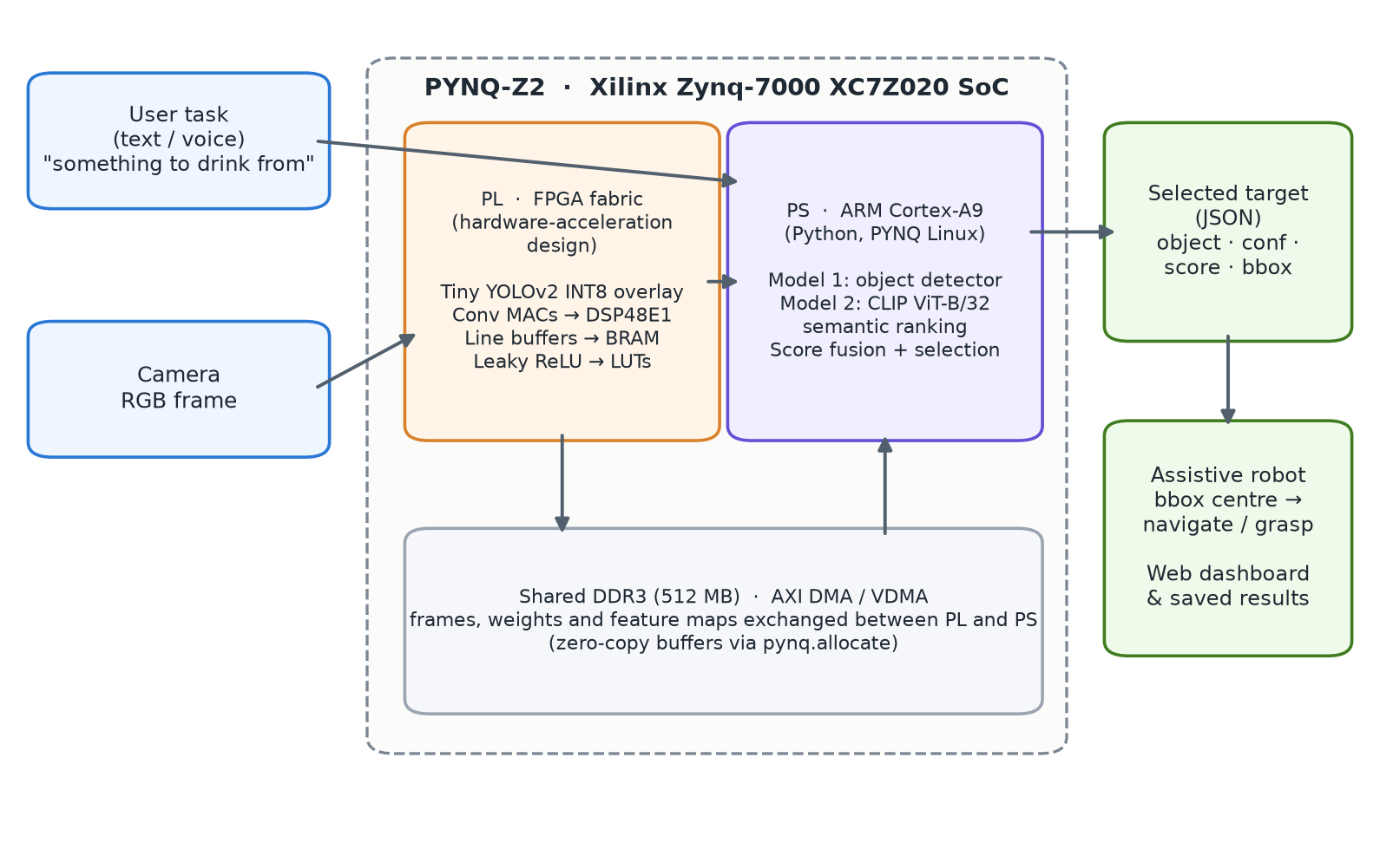
Figure 3.1: System architecture on the PYNQ-Z2 (Zynq-7000 XC7Z020). The PL block is the hardware-acceleration design; the evaluated pipeline runs on the PS

3.1.2 Hardware and Software Environment
Table 3.1: Development and target environment
Component | Details
Target board | TUL PYNQ-Z2 — Xilinx Zynq-7000 XC7Z020 SoC, 512 MB DDR3, PYNQ Linux image
Board processor (PS) | Dual-core ARM Cortex-A9
Board FPGA fabric (PL) | Artix-7 class programmable logic: 53,200 LUTs, 220 DSP48E1 slices, 140 × 36 Kb BRAM
Host computer | Windows 11 laptop, 12-thread CPU, NVIDIA GeForce GTX 1650 (4 GB) used for training
Language / runtime | Python 3.11 (host), Python on PYNQ Linux (board)
Deep-learning stack | PyTorch 2.3.1 (CPU and CUDA 12.1 builds), Ultralytics 8.4, OpenCLIP 3.3 (ViT-B/32, OpenAI weights)
Vision / imaging | OpenCV 4.11, Pillow
Interfaces | OpenCV desktop camera UI, PuTTY/SSH terminal bridge, browser dashboard (HTML/JavaScript + Python standard-library HTTP server)

3.2 Process Work Flow

3.2.1 Processing Pipeline
The software pipeline is shown in Figure 3.2. It is implemented as two models connected by a small amount of glue logic:
- Model 1 — object detection. Produces candidate objects with class, confidence and bounding box. Three interchangeable detectors are supported (Section 3.3).
- Model 2 — task-aware semantic ranking. Scores every candidate against the task using CLIP and selects the best one (Section 3.4).
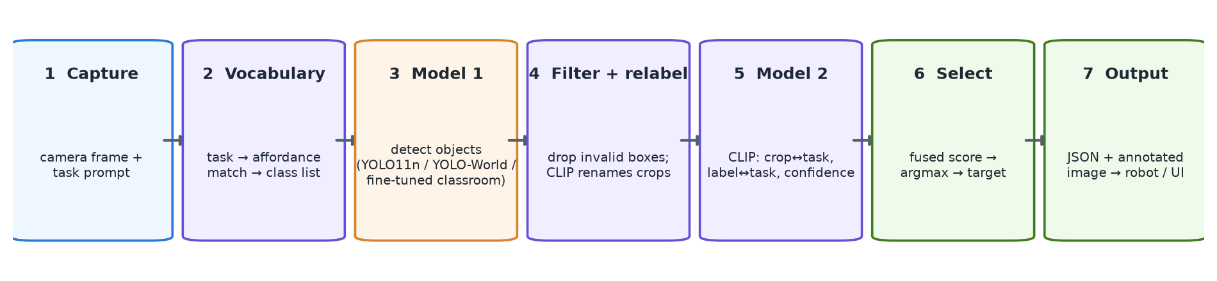
Figure 3.2: End-to-end processing pipeline from camera frame and task prompt to the robot target
The steps are: (1) capture the frame and task; (2) for the open-vocabulary detector, build a short list of candidate object names from the task; (3) run Model 1; (4) filter invalid detections and, for open-vocabulary boxes, re-label each crop with CLIP; (5) compute the fused task-relevance score of every candidate in Model 2; (6) select the highest-scoring object; (7) save and return the JSON target and an annotated image.

3.2.2 Data Flow and Output Format
Each run produces a JSON record containing the task, the detector used, the candidate vocabulary, every detection, the ranked candidates with their individual similarity terms, the selected object and the processing time. An abridged example from a real run is shown in Appendix 2. The selected object’s bounding box [x1, y1, x2, y2] gives the robot a target whose centre can be used for navigation or grasp planning.

3.3 Model 1: Object Detection
Three detectors can be selected at run time. They share one output format, so Model 2 is independent of the choice.
Table 3.2: Model 1 detector options
Option | Model | Classes | Notes
YOLO · 80 classes | YOLO11n (Ultralytics), COCO-pretrained | 80 fixed COCO classes | Small (≈ 5.4 MB); the detector used at Review-II
Open-vocabulary | YOLO-World v2-S + CLIP re-labelling | Any object named in the task (220-object vocabulary + free text) | Host PC only; heaviest option
Fine-tuned · classroom | YOLO11n fine-tuned on Open Images | 46 classroom and room classes | Fixed-class, 5.5 MB; suited to board deployment

3.3.1 YOLO11n (COCO)
YOLO11n is the nano variant of the Ultralytics YOLO11 family [16], pre-trained on COCO [18]. It detects the 80 COCO categories (person, cup, bottle, chair, laptop, cell phone and so on) with a confidence threshold of 0.20; if nothing passes, the threshold is relaxed to 0.05 so that Model 2 still receives candidates.

3.3.2 Open-Vocabulary Detection with YOLO-World
Many everyday objects that an assistive robot is asked for — headphones, keys, glasses, a towel, an ID card — are not COCO classes, so a fixed-class detector cannot find them at all. YOLO-World [13] accepts its class list as text at run time. The system builds that list from the task (Section 3.4.1), runs YOLO-World with a low confidence threshold (0.05), and then passes each box to CLIP for re-labelling (Section 3.4.4).

3.3.3 Fine-Tuned Classroom Detector
A YOLO11n model was fine-tuned on 46 classroom and room object classes (Section 3.5). It is fast and fixed-class, which makes it the appropriate kind of model for export to ONNX/INT8 and deployment on the PYNQ-Z2.

3.4 Model 2: Task-Aware Semantic Ranking
Model 2 uses the OpenCLIP [22] implementation of CLIP ViT-B/32 with the original OpenAI weights. Text and images are encoded into 512-dimensional L2-normalised vectors, so the cosine similarity of two vectors is their dot product:
sim(a, b) = (a · b) / (‖a‖ ‖b‖) (3.1)

3.4.1 Task-to-Object Vocabulary with Affordance Descriptions
For the open-vocabulary detector the task must first be turned into candidate object names. A vocabulary of 220 objects (the 80 COCO classes, everyday household items and about 60 classroom and room objects) was written, each with a short affordance description of what it is used for — for example “headphones, used to listen to music or audio” or “duster, used to erase and wipe the board clean”. The task text is compared with these descriptions rather than with bare object names, because CLIP links a use to an object much more reliably when the object is described by its function. If the task itself is a short noun phrase (“headphones”, “red cup”), it is also added verbatim as the first class. The eight best-matching objects form the detector’s class list; person is excluded unless the task mentions a person.

3.4.2 Hubness Correction
In high-dimensional embedding spaces some points are close to almost everything — a phenomenon known as hubness [19]. In early tests the entries toy, book and cake appeared in the candidate list for almost every task. Each vocabulary entry’s mean similarity to all other entries is therefore subtracted from its task similarity:
sim′(t, oᵢ) = sim(t, oᵢ) − (1 / (N−1)) Σⱼ≠ᵢ sim(oᵢ, oⱼ) (3.2)

3.4.3 Score Fusion and Selection
Each detected candidate i is scored with three signals: the similarity between the task and the image crop of the candidate, the similarity between the task and the candidate’s label description, and the detector confidence. Raw CLIP cosines lie in a narrow band (about 0.2–0.3 for image-text and about 0.8 for text-text pairs), so the two similarity terms are converted to relative probabilities across the candidates using CLIP’s logit scale of 100 before fusion:
pᵢ = softmax(100 · sim(t, cropᵢ)), qᵢ = softmax(100 · sim(t, labelᵢ)) (3.3)
scoreᵢ = 0.55 · pᵢ + 0.25 · qᵢ + 0.20 · confᵢ (3.4)
Because person is the most frequent and most confidently detected COCO class, its score is multiplied by 0.5 unless the task refers to a person. The candidate with the highest score is selected. The image-crop term dominates the fusion because it is the only signal that looks at the actual pixels of each candidate.
Table 3.3: Score fusion at Review-II and in the final system
Aspect | Review-II | Final system
Task embedding | Embedding of the nearest of 14 fixed COCO-Tasks phrases | Embedding of the user’s actual text
Label term | cos(task, label) (raw) | softmax over candidates of cos(task, label description)
Image term | (cos(task, crop) + 1) / 2 | softmax over candidates of cos(task, crop)
Fusion | 0.65 · (0.7 · label + 0.3 · conf) + 0.35 · image | 0.55 · image + 0.25 · label + 0.20 · conf
Person bias | none | × 0.5 unless the task mentions a person

3.4.4 CLIP Re-labelling of Open-Vocabulary Boxes
YOLO-World places boxes accurately but can confuse similar class names: headphones held in a hand were labelled microphone. Each open-vocabulary box is therefore re-labelled by zero-shot CLIP classification of its crop against the prompts “a photo of a ⟨class⟩” for every class in the current list; the detector’s original label is kept for traceability.

3.5 Fine-Tuning the Classroom Object Detector

3.5.1 Dataset Construction
Training images and human-verified bounding boxes were taken from the validation and test splits of Google Open Images [17] (the 2 GB training-annotation file was not required). Classes were chosen for classroom and room scenes, and related Open Images categories were merged (for example Table and Kitchen & dining room table → table; Bookcase and Shelf → bookshelf). Five planned classes — eraser, pencil sharpener, stapler, scissors and ring binder — had only 0–7 boxed images in these splits and were dropped. For each class up to 40 images were selected, rarest classes first; images were downloaded from the public Open Images bucket, resized to at most 640 px and split 85/15 into training and held-out validation sets by a hash of the image ID.
Table 3.4: Classroom dataset summary
Property | Value
Source | Google Open Images (validation + test splits, human-verified boxes)
Classes | 46 (classroom, office and room objects)
Images | 1,342 (1,167 training, 175 held-out validation)
Validation instances | 384 boxes
Image size | Longest side ≤ 640 px
Split | Deterministic, by MD5 hash of the image ID (15% validation)

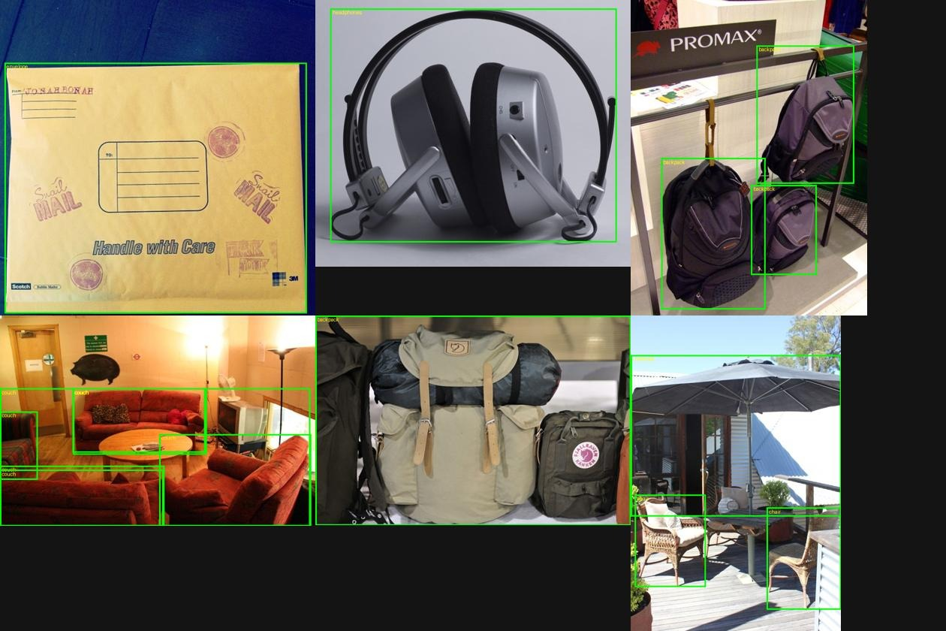
Figure 3.3: Sample training images with their Open Images bounding boxes drawn (envelope, headphones, backpack, couch, umbrella/chair)
The class list is: whiteboard, desk, table, chair, stool, bench, couch, book, pen, pencil case, ruler, calculator, envelope, laptop, monitor, keyboard, mouse, printer, tablet, tv, remote control, cell phone, headphones, microphone, backpack, handbag, bottle, mug, glasses, clock, watch, lamp, ceiling fan, light switch, door, window, curtain, bookshelf, cupboard, dustbin, box, poster, picture frame, towel, helmet and umbrella.

3.5.2 Training Configuration
Two fine-tuning runs were performed from the COCO-pretrained YOLO11n weights (Table 3.5). The first ran on the CPU with a frozen backbone and smaller images to keep training tractable; the second ran on the GTX 1650 GPU with the whole network trainable and full-resolution images. A batch size of 16 at 640 px exceeded the 4 GB of GPU memory and caused Windows to spill into shared system memory (4 minutes per epoch), so the batch size was reduced to 6, giving about 1 minute per epoch. Both runs used early stopping on validation mAP50.
Table 3.5: Fine-tuning hyper-parameters
Parameter | Run 1 (CPU) | Run 2 (GPU)
Device | 12-thread CPU | NVIDIA GTX 1650, 4 GB
Image size | 416 px | 640 px
Batch size | 16 | 6
Frozen layers | first 10 (backbone) | none
Initial learning rate | 0.005, cosine schedule | 0.01, cosine schedule
Mosaic augmentation | on, disabled for last 5 epochs | on, disabled for last 5 epochs
Early-stopping patience | 12 epochs | 20 epochs
Epochs completed | 20 (best at epoch 8) | 34 (best at epoch 18)
Training time | 41 minutes | ≈ 35 minutes

3.6 Hardware Platform and On-Board Execution

3.6.1 The PYNQ-Z2 Board
PYNQ (Python Productivity for Zynq) [20] is an open-source framework from AMD/Xilinx that runs Linux on the Zynq’s ARM processor and lets Python programs load FPGA overlays (bitstreams) and exchange data with them through shared memory. The PYNQ-Z2 [21] combines this with the XC7Z020 device, 512 MB of DDR3, Ethernet, USB-UART, HDMI in/out and Raspberry-Pi and Arduino headers.
Table 3.6: PYNQ-Z2 resources relevant to this project
Resource | Specification | Role in the design
Processing system | Dual-core ARM Cortex-A9 | Python pipeline, CLIP ranking, orchestration
Logic | 53,200 LUTs, 106,400 flip-flops | Activation functions, control logic
DSP slices | 220 DSP48E1 | Convolution multiply-accumulate
Block RAM | 140 × 36 Kb (4.9 Mb) | Feature-map line buffers, weights
Memory | 512 MB DDR3 shared by PS and PL | Frames, weights, results (AXI DMA)
Connectivity | Gigabit Ethernet, micro-USB UART/JTAG | SSH/Jupyter access, serial console

3.6.2 Execution on the Board
Board setup. The PYNQ-Z2 was connected directly to the laptop with an Ethernet cable, and its Python environment was prepared from the Jupyter terminal served by the board (Figure 3.4). The OpenBLAS libraries were installed with apt, and NumPy was pinned to version 1.23.5. Building NumPy from source on the board’s ARM processor was very slow, so the build was cancelled and pre-built armv7l (cp310) wheels from the community pytorch-arm project were installed instead, followed by PyTorch for the board’s 32-bit ARM Linux.
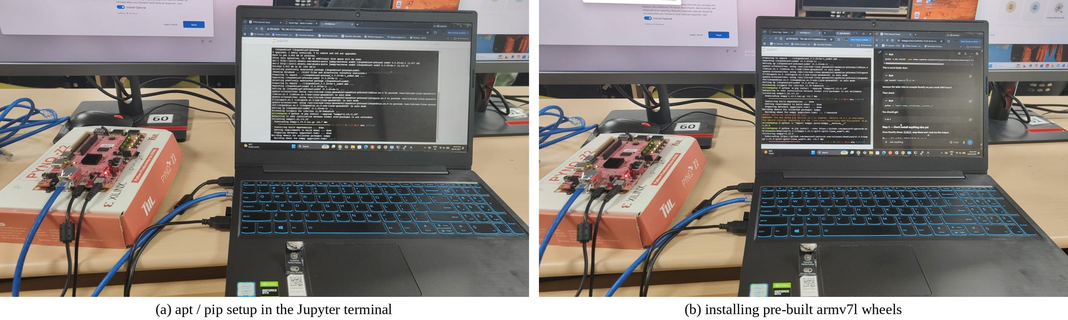
Figure 3.4: Preparing the PYNQ-Z2 software environment over Ethernet: (a) installing OpenBLAS and NumPy through the board’s Jupyter terminal; (b) installing pre-built armv7l wheels
Running the pipeline. The complete Python pipeline (YOLO_custom/orchestrator.py: detection followed by CLIP-based ranking and selection) was executed on the PYNQ-Z2’s ARM processor under PYNQ Linux, accessed from the laptop over Ethernet and a PuTTY/SSH session. The run asked for an image path and a text task and printed the ranked detections and the final selection as JSON on the board (Figure 3.5). Results were copied to the host over SCP. Four recorded videos of this demonstration are included in the web dashboard.
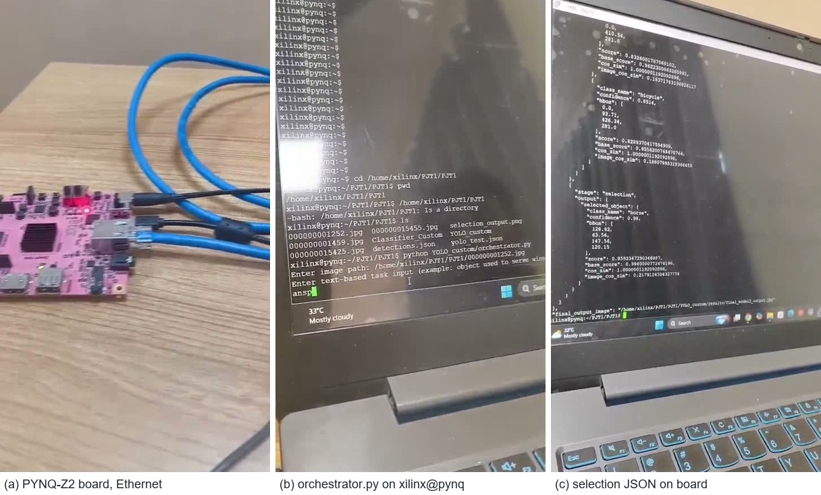
Figure 3.5: On-board execution: (a) the PYNQ-Z2 board connected over Ethernet; (b) orchestrator.py running in the xilinx@pynq shell; (c) the selection JSON printed by the board

3.6.3 Hardware-Acceleration Design
The design maps the detector to the programmable logic as a Tiny YOLOv2 INT8 overlay, following the resource analysis of Zhang et al. [6] for XC7Z020-class devices and the quantised dataflow approach of FINN [7]. In this mapping convolution multiply-accumulates are assigned to DSP48E1 slices, feature-map line buffers to BRAM and the leaky-ReLU and bias operations to LUT logic. Frames are transferred into the PL with AXI VDMA and detection results returned to the PS through shared DDR3 buffers allocated with pynq.allocate. The target is about 30 frames per second within a power envelope below 15 W.
The evaluation in Chapter 4 measures the detection-and-ranking pipeline in software. Benchmarking FPS, latency, power and LUT/DSP/BRAM utilisation of the PL detector, and live camera streaming through AXI VDMA, are listed as future work (Chapter 5). The fine-tuned 46-class YOLO11n model (5.5 MB, fixed classes) is exportable to ONNX and INT8 for this hardware path.

3.6.4 Board Connection Detection
To make the hardware state visible during a demonstration, the dashboard server checks every four seconds whether the board is reachable. It probes the board’s default address (192.168.2.99) for SSH (port 22), Jupyter (port 9090) and HTTP (port 80), and on Windows queries the device list for FTDI USB-UART devices (vendor ID 0403) that appear as COM ports. Bluetooth serial ports present on the laptop are correctly ignored. When the board appears the header indicator turns green and names the connection (for example PYNQ-Z2 connected · 192.168.2.99).

3.7 User Interfaces

3.7.1 Desktop Camera Interface (OpenCV)
orchestrator.py provides a live OpenCV camera window with an on-screen text box and SUBMIT/RESET buttons (Figure 3.6). Inference runs in a background thread so the video does not freeze, and an OpenCV MIL tracker keeps the selected box on the object as it moves in the live feed; the tracker itself runs in a separate thread so the display stays at camera frame rate.
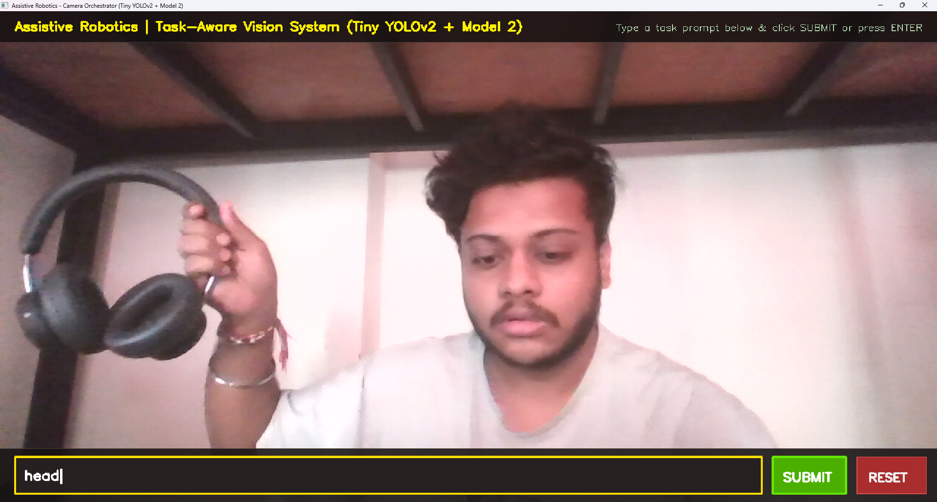
Figure 3.6: Desktop OpenCV camera interface with the task prompt box and SUBMIT / RESET buttons

3.7.2 PuTTY Terminal Bridge
putty_bridge.py exposes the pipeline as an interactive terminal session over a TCP socket, so the pipeline can be driven from a PuTTY console and its ranked detections and reasoning trace viewed as coloured text — the same workflow used to run the pipeline on the PYNQ-Z2 over SSH.

3.7.3 Web Dashboard
A browser dashboard served by a Python standard-library HTTP server (PJT1/web/server.py) was built for demonstration and evaluation (Figures 3.7 and 3.8). Its features are:
- live webcam view and a frozen identified target view with the selected box and all other candidates;
- choice of the three Model 1 detectors, example task prompts and image upload;
- a pipeline progress strip and a terminal panel that prints every detection, the affordance matches, the ranking table and the saved result.json;
- automatic saving of every run to saved_results/<timestamp>_<task>/ (input image, annotated image and JSON) and a Saved results strip that reloads them;
- a PYNQ-Z2 connection indicator that detects the board over Ethernet or over USB;
- results charts, the Review-II result gallery, the demonstration videos, and a light theme for projectors.
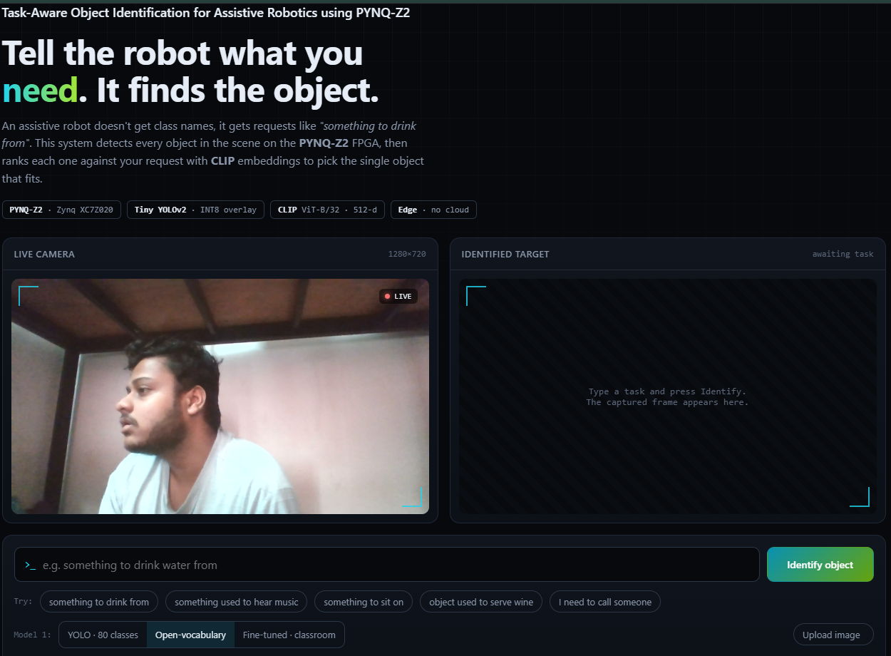
Figure 3.7: Web dashboard — project title, live camera and identified-target panels
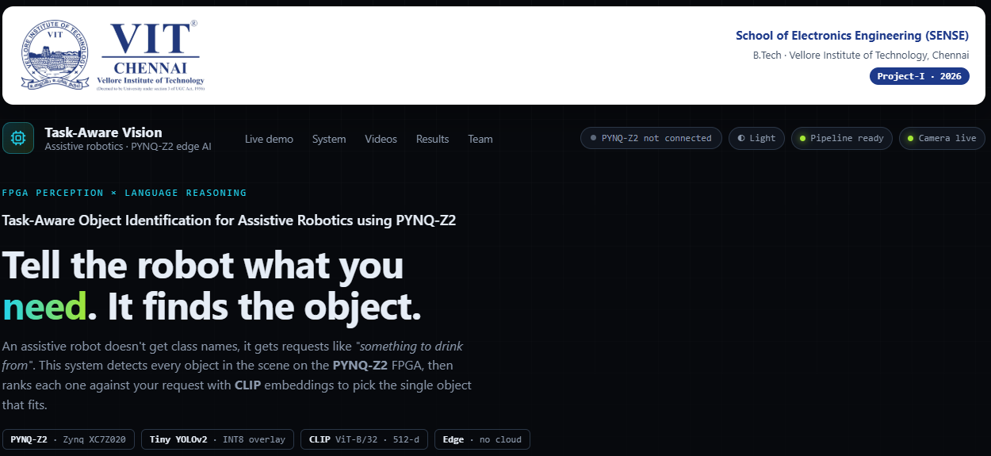
Figure 3.8: Web dashboard header with the institutional banner, navigation and the PYNQ-Z2 connection indicator

3.8 Challenges and Solutions
Table 3.7: Problems found during development and their resolution
Problem | Cause | Solution
System always selected person | Task replaced by the nearest of 14 fixed task phrases; detector confidence weighted 30%; person is the most confident COCO class | Score with the user’s own text; image-crop term dominant; person penalty (Section 3.4.3)
Headphones never found | Headphones are not a COCO class (detected as hair drier) | Open-vocabulary detector with task-derived class list
Headphones labelled microphone | YOLO-World confuses similar names | CLIP re-labelling of each box (Section 3.4.4)
Task prompts mapped to the wrong objects | CLIP is weak at linking a use to a bare name; hub objects in every list | Affordance descriptions and hubness correction (10/14 → 14/14)
Open-vocabulary request took ≈ 10 s | CLIP text model (338 MB) reloaded on every request; 220 descriptions re-encoded every time | Cached text encoder and vocabulary embeddings (≈ 2 s)
Selected box drifted from the object | Box drawn at fixed pixels on new live frames | Background inference + MIL tracker; frozen result view in the dashboard
GPU training: 4 min/epoch, then out-of-memory | Batch 16 at 640 px exceeds 4 GB; memory shared with other apps | Batch size 6 (≈ 1 min/epoch)
Training process crashed at epoch 34 | Windows paging file exhausted (error 1455) | Best checkpoint (epoch 18) already saved; evaluated and deployed

CHAPTER 4

Results and Discussion

4.1 Evaluation Setup
Five aspects were evaluated: (i) the accuracy of the fine-tuned classroom detector on held-out images; (ii) the task-to-object mapping of the vocabulary stage; (iii) end-to-end behaviour on real camera scenes and on the Review-II test set; (iv) processing time; and (v) a comparison with existing solutions and with the Review-II version of this system. Detection accuracy is reported as mAP50 (mean average precision at an IoU threshold of 0.5) and mAP50-95 (averaged over IoU thresholds from 0.5 to 0.95). All timing figures are measured on the host laptop CPU.

4.2 Fine-Tuned Classroom Detector

4.2.1 Training Behaviour
Figure 4.1 shows validation mAP50 after every epoch for both runs. The CPU run with a frozen backbone learned quickly and peaked at epoch 8 (52.3%); the GPU run with the full network trainable rose more slowly but reached a higher peak at epoch 18 (53.3%) and remained around 50–52% afterwards, indicating that the model had converged for this dataset size.
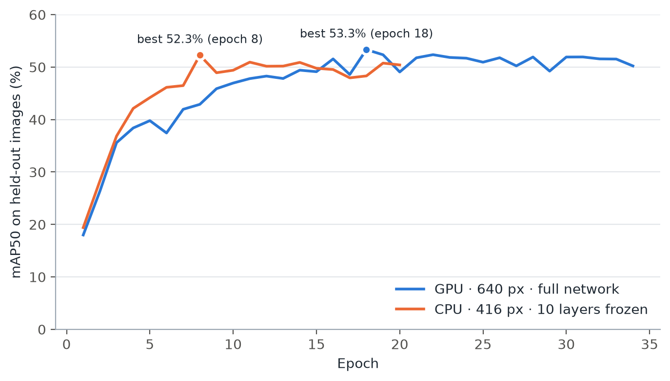
Figure 4.1: Validation mAP50 per epoch for the CPU run (416 px, frozen backbone) and the GPU run (640 px, full network)

4.2.2 Overall Accuracy
Table 4.1: Accuracy of the two fine-tuned models on the 175 held-out images (384 boxes)
Model | Evaluated at | Precision | Recall | mAP50 | mAP50-95
Run 1 (CPU) | 416 px | — | — | 51.8% | 39.9%
Run 2 (GPU) — deployed | 640 px | 54.5% | 48.9% | 53.1% | 40.6%

The GPU-trained model was more accurate and was deployed as the Fine-tuned · classroom detector; the CPU model is kept as a backup. Each model is evaluated at the image size it was trained with.

4.2.3 Per-Class Accuracy
Figure 4.2 shows AP50 for all 46 classes. Compact, visually distinctive objects such as the calculator, envelope, mouse, bottle, lamp, light switch and ceiling fan reach AP50 above 94%, whereas large or context-dependent categories — desk, window, door, table, box and bench — fall below 20%. These categories have ambiguous extents and are frequently present but unlabelled in Open Images photos, because each image is only exhaustively labelled for some classes. Several classes have only two to ten validation images, so individual per-class values carry considerable uncertainty.
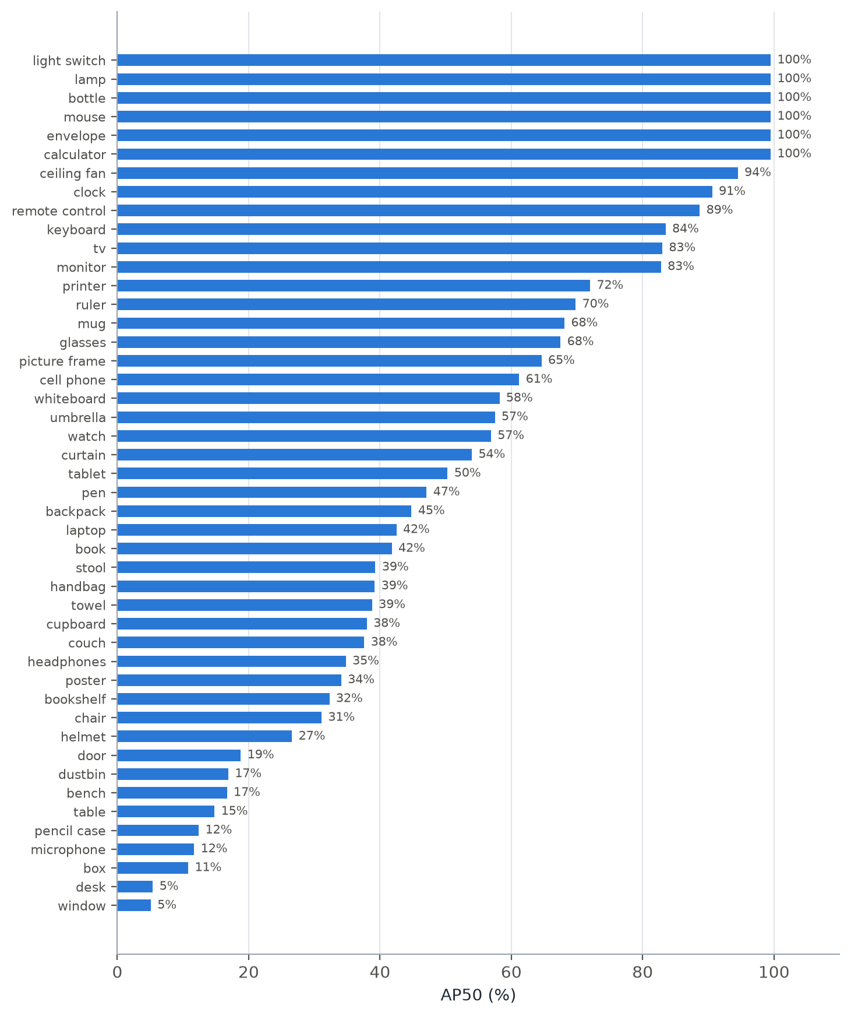
Figure 4.2: AP50 of the deployed classroom detector for each of the 46 classes on the held-out images
Table 4.2: Best and worst classes (deployed model, held-out images)
Class | Precision | Recall | AP50 | Class | Precision | Recall | AP50
lamp | 100% | 90.9% | 99.5% | window | 4.8% | 2.4% | 5.1%
light switch | 80.5% | 100% | 99.5% | desk | 0.0% | 0.0% | 5.4%
mouse | 100% | 95.5% | 99.5% | box | 15.5% | 20.0% | 10.8%
envelope | 100% | 97.2% | 99.5% | microphone | 43.6% | 14.3% | 11.7%
bottle | 24.7% | 100% | 99.5% | pencil case | 36.6% | 14.6% | 12.4%
calculator | 52.7% | 100% | 99.5% | table | 22.1% | 16.3% | 14.8%
ceiling fan | 76.9% | 84.4% | 94.5% | bench | 21.6% | 33.3% | 16.7%
clock | 81.2% | 80.0% | 90.6% | dustbin | 34.2% | 16.7% | 16.9%

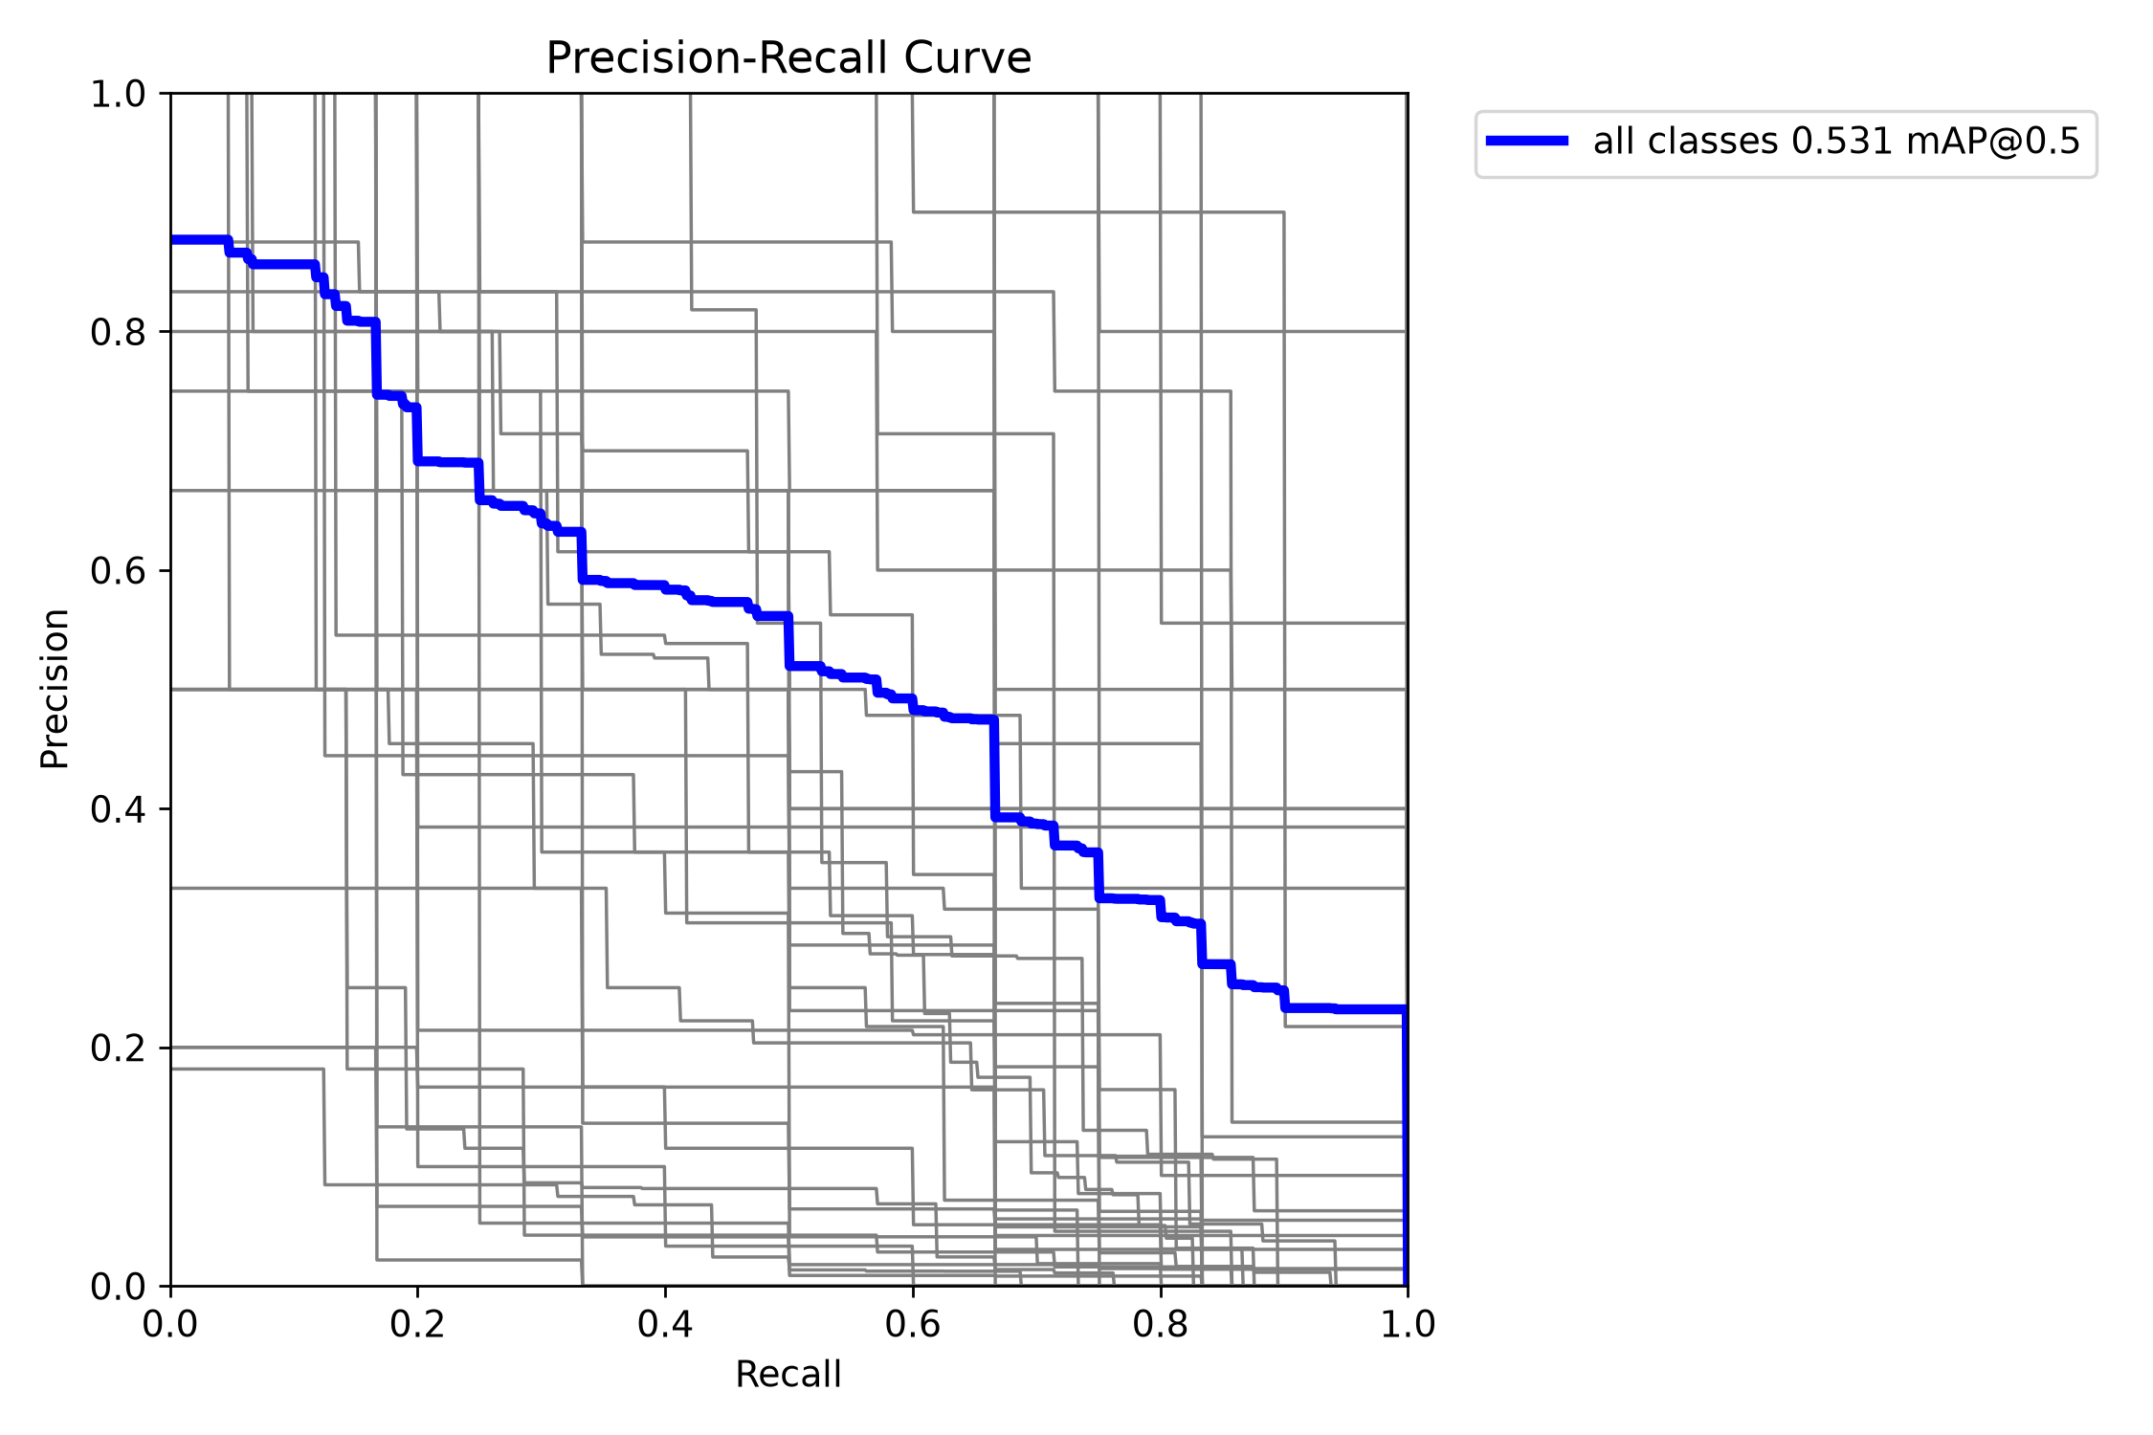
Figure 4.3: Precision–recall curves of the deployed classroom detector (thick line: mean over all classes)

4.3 Task-to-Object Mapping
The vocabulary stage was evaluated on 28 task prompts, each with one expected object: 14 everyday tasks and 14 classroom tasks. A prompt counts as mapped if the expected object appears in the eight-object candidate list handed to the detector; the rank of the expected object is also reported. Before the affordance descriptions and hubness correction were introduced, only 10 of the first 14 prompts were mapped.
Table 4.3: Task-to-object mapping on 28 prompts (final system)
# | Task prompt | Expected | Rank | Top-3 candidates
1 | Something to used to hear music | headphones | 3 | earphones, earbuds, headphones
2 | I want to listen to music | headphones | 3 | earbuds, earphones, headphones
3 | something to dry my hands | towel | 2 | soap, towel, sink
4 | something to drink from | cup | 1 | cup, bottle, glass
5 | something to sit on | chair | 6 | stool, bench, sofa
6 | I need to call someone | cell phone | 1 | cell phone, person, earphones
7 | object used to serve wine | wine glass | 1 | wine glass, plate, cup
8 | something to cut paper | scissors | 1 | scissors, paper, sticky notes
9 | I want to read something | book | 1 | book, tablet, textbook
10 | something to tell the time | clock | 2 | watch, clock, book
11 | I want to brush my teeth | toothbrush | 1 | toothbrush, toothpaste, brush
12 | something to write with | pen | 1 | pen, paper, marker
13 | I need to see clearly | glasses | 1 | glasses, sunglasses, highlighter
14 | something to carry my things | backpack | 4 | bag, handbag, lunch box
15 | something to erase the board | duster | 1 | duster, whiteboard, notice board
16 | write on the wall for teaching | whiteboard | 1 | whiteboard, blackboard, chalk
17 | something to show slides | projector | 4 | presentation clicker, projector screen, sticky notes
18 | something to measure a line | ruler | 1 | ruler, tape, microphone
19 | something to sharpen my pencil | sharpener | 1 | sharpener, pencil, pencil case
20 | something to rub out a mistake | eraser | 8 | highlighter, sticky notes, book
21 | something to print documents | printer | 1 | printer, paper, exam paper
22 | something to store files | pen drive | 2 | file folder, pen drive, sticky notes
23 | something to show my identity | id card | 1 | id card, book, mirror
24 | something to cool the room | ceiling fan | 2 | air conditioner, ceiling fan, fan
25 | protect my head while riding | helmet | 1 | helmet, hat, cap
26 | something to clean my hands | hand sanitizer | 2 | soap, hand sanitizer, sink
27 | something to put my books on | bookshelf | 2 | book, bookshelf, textbook
28 | a place to sit and study | desk | 2 | student bench, desk, bench

All 28 expected objects appear in the candidate list (28/28); the expected object is ranked first for 15 prompts and within the top three for 24. Many non-first rankings are reasonable alternatives — watch before clock for telling the time, stool and bench before chair for sitting — and the final choice between them is made by Model 2 from the image. The prompts were written by the project team, so these figures indicate behaviour on representative requests rather than an independent benchmark.

4.4 End-to-End Results

4.4.1 Case Study: “Something Used to Hear Music”
This prompt, with the user holding headphones beside their face, exposed the main weaknesses of the Review-II pipeline (Table 4.4). The COCO detector could not detect headphones (it reported them as hair drier at 0.47 confidence), the task was replaced by the fixed phrase “step on something”, and the confidence term favoured the person (0.86). The image-crop similarity was the only signal that preferred the headphones (0.287 versus 0.225), but it carried almost no weight. In the final system, the open-vocabulary detector found the headphones, CLIP re-labelled the box from microphone to headphones, and the headphones were selected.
Table 4.4: Headphones case study, Review-II versus final system
Stage | Review-II pipeline | Final pipeline
Detector output | person 0.86; hair drier 0.47 (the headphones) | box on the headphones (labelled microphone)
Task representation | nearest fixed task: “step on something” | user’s text; candidates earphones, earbuds, headphones…
Label after CLIP re-labelling | — | headphones
Crop–task similarity | person 0.225 · headphones 0.287 (weight ≈ 1%) | dominant term (55%)
Selected object | person (0.780 vs 0.661) | headphones (score 0.61)

4.4.2 Real-World Scenes (Saved Dashboard Results)
Every request made through the web dashboard is saved automatically with its input image, annotated image and result.json (Section 3.7.3). Twelve such runs were recorded with the open-vocabulary detector: four on live webcam frames in a hostel room (16 October 2026) and eight on photographs of the university computer laboratory and classroom (20 October 2026). Table 4.5 lists all twelve exactly as saved, including the failures.
Table 4.5: All saved dashboard runs (open-vocabulary detector)
# | Scene | Task prompt | Selected object | Conf. | Score | Time | Outcome
1 | Hostel room | fan | ceiling fan | 0.723 | 0.515 | 5.7 s | Correct
2 | Hostel room | clothes | clothes | 0.088 | 0.253 | 5.7 s | Correct
3 | Hostel room | headphones | headphones | 0.200 | 0.526 | 3.6 s | Correct
4 | Hostel room | Bottle | water bottle | 0.179 | 0.548 | 3.1 s | Correct
5 | Computer lab | Laptop | laptop | 0.212 | 0.301 | 7.3 s | Correct
6 | Computer lab | Monitor | monitor | 0.843 | 0.532 | 5.0 s | Correct
7 | Computer lab | something to drink from | bottle | 0.431 | 0.551 | 8.8 s | Correct
8 | Corridor | Fire Extinguisher | fire extinguisher | 0.757 | 0.824 | 4.9 s | Correct
9 | Computer lab | WhiteBoard | whiteboard | 0.441 | 0.828 | 8.2 s | Correct
10 | Classroom | Curtains | curtains | 0.112 | 0.332 | 7.8 s | Correct
11 | Classroom | Fan | microphone | 0.131 | 0.748 | 3.2 s | Wrong label (box on fan)
12 | Computer lab | hair | — | — | — | 1.0 s | Missed

Ten of the twelve requests selected the correct object. Figure 4.4 shows the hostel-room runs and Figure 4.5 the laboratory and classroom runs. Two results are particularly informative. The fire extinguisher is not in the 220-object vocabulary; it was found because short noun phrases are passed to the detector verbatim, showing that the open-vocabulary path generalises beyond its vocabulary. The something to drink from request was a task rather than an object name, and the affordance vocabulary mapped it to a bottle that was then located on the floor beside a desk.
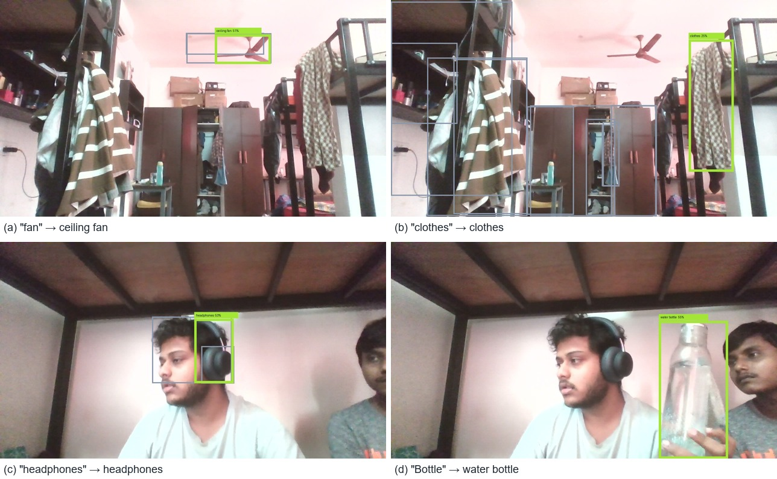
Figure 4.4: Saved dashboard results on live webcam frames in a hostel room. Green: selected object; grey: other candidates considered by Model 2
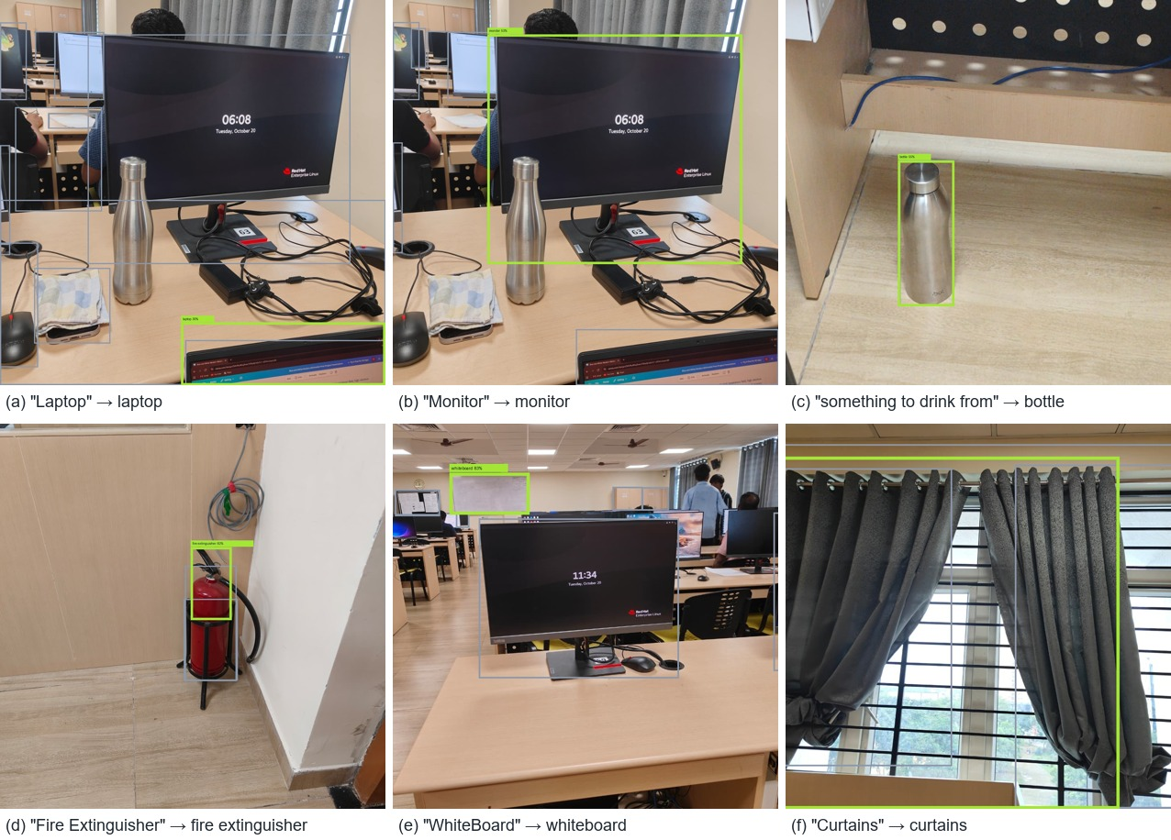
Figure 4.5: Saved dashboard results on photographs of the university computer laboratory and classroom
The two failures are shown in Figure 4.6. For Fan the box was placed correctly on the ceiling fan’s motor and blade, but CLIP re-labelled the crop as microphone — the round hub viewed from below resembles a microphone head, and the tight crop omits most of the blades that identify a fan. For hair no candidate passed the detection threshold: the only hair in the frame belongs to a person partly hidden behind a monitor at the image edge. Detection confidences for these open-vocabulary runs are often low (0.09–0.20 for clothes, headphones and the bottle), which is expected for YOLO-World on uncommon objects; Model 2 still ranks such candidates correctly because the image-crop similarity dominates the score. Processing times of 3–9 s on these 1280-pixel images are higher than in Table 4.7 because each additional candidate requires one more CLIP image encoding.
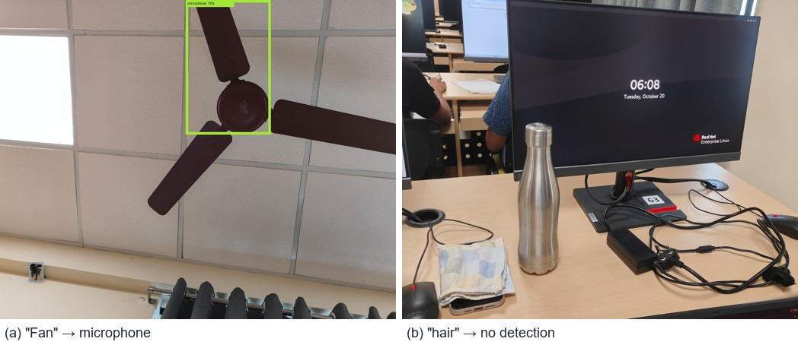
Figure 4.6: Failure cases: (a) the fan is boxed correctly but re-labelled as a microphone; (b) no detection for “hair”

4.4.3 Review-II Test Set
At Review-II the pipeline was tested with 14 task prompts on COCO test images (Table 4.6, Figure 4.7). Ten selections are plausible (for example wine glass, bottle opener scene → bottle, knife for butter, couch for the carpet scene), while some reveal the limits of label-level reasoning — “sit in a relaxed manner” selected a toilet, and four tasks about a person performing an action selected the person. Across these queries the mean final score was 0.755 and the mean detection confidence 0.794.
Table 4.6: Review-II task queries and selections (COCO test images)
Task | Selected | Conf. | Score
object used to serve wine | wine glass | 0.915 | 0.807
bear (beer) bottle open | bottle | 0.877 | 0.814
item to smear butter on bread | knife | 0.906 | 0.766
substance which contain sugar | cup | 0.869 | 0.775
i want to sit in a relaxed manner | toilet | 0.876 | 0.763
something is being placed to pound carpet | couch | 0.932 | 0.754
object that is use to control fire | fire hydrant | 0.880 | 0.764
something which smells good | vase | 0.911 | 0.748
item which provide carbohydrate is taking out of fire | potato | 0.423 | 0.644
something is to be taken away from tea cup | orange | 0.652 | 0.697
the person stepped on something | person | 0.927 | 0.796
someone is watering the plant | person | 0.793 | 0.743
someone digs hole | person | 0.452 | 0.682
someone is opening parcel | person | 0.527 | 0.719

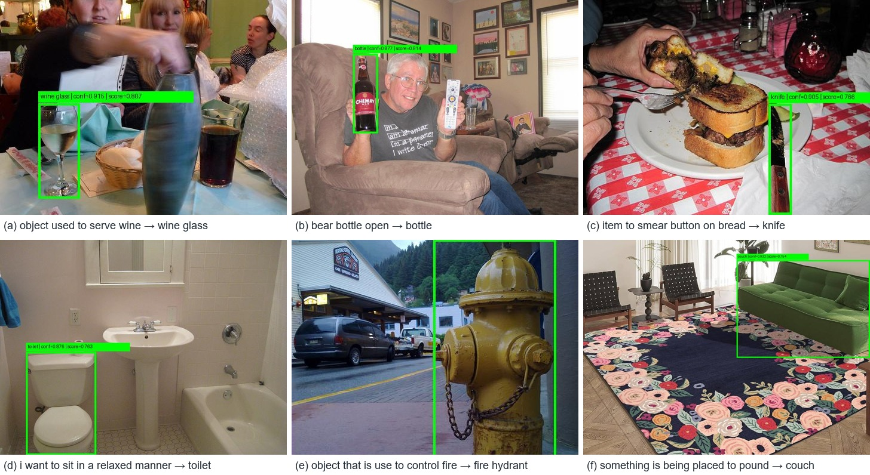
Figure 4.7: Selected examples from the Review-II test set with the selected object outlined

4.5 Processing Time
Table 4.7: Median end-to-end time per request on the host laptop CPU
Model 1 option | Objects it can find | Time* | Board-deployable
YOLO · 80 classes | 80 COCO classes | 1.8 s | Yes — ran on the board
Open-vocabulary | Any named object | 4.4 s | No — host only
Fine-tuned · classroom | 46 classroom/room classes | 1.2 s | Designed for it (ONNX/INT8 export)

*Detection plus CLIP semantic ranking, median of three test images with a matching task, models already loaded. Open-vocabulary requests were reduced from about 10 s to 2–4 s by caching the CLIP text encoder and the vocabulary embeddings; the remaining cost is dominated by encoding one image crop per candidate with CLIP on the CPU.

4.6 Comparison with Existing Solutions
Table 4.8 compares the final system with the published approaches reviewed in Chapter 2 on the capabilities needed by an assistive robot. The task-driven methods [9]–[11] report their accuracy on the COCO-Tasks benchmark, which was not used in this project, so the comparison is made on capability rather than on a shared accuracy number.
Table 4.8: Capability comparison with existing solutions
Approach | Input | Free-form task text | Objects outside a fixed list | One robot-ready target | Runs on embedded board
YOLO / Tiny YOLOv2 [1], [2] | Image | No | No | No — list of labels | Partly (tiny variants)
FPGA YOLO accelerators [3]–[7] | Image | No | No | No — list of labels | Yes
COCO-Tasks [9], TOIST [10] | Image + one of 14 tasks | No | No | Yes | No — GPU
CoTDet [11] | Image + one of 14 tasks | No | No | Yes | No — GPU + LLM
OWL-ViT [12], YOLO-World [13] | Image + object names | No — names only | Yes | No — all matches | No — GPU
CLIPort [14], SayCan [15] | Image + instruction | Yes | Partly | Action policy | No — GPU / cloud
This work | Image + any task text | Yes | Yes (open-vocab. mode) | Yes — JSON + box | Yes — ran on PYNQ-Z2 PS

Table 4.9 compares the final system with its own Review-II version, measured on the same prompts and scenes.
Table 4.9: Improvement of the final system over the Review-II baseline
Measure | Review-II | Final system
Task representation | Nearest of 14 fixed phrases | User’s own text
Candidate-list hit rate, original 14 prompts | 10 / 14 | 14 / 14
Candidate-list hit rate, all 28 prompts | — | 28 / 28 (top-1: 15, top-3: 24)
Objects outside COCO (headphones, clothes, fire extinguisher) | Not detectable | Detected
Headphones case study | Selected person | Selected headphones
Real-world requests (12 saved runs) | — | 10 / 12 correct
Classroom-object detector | None | 46 classes, 53.1% mAP50
Open-vocabulary request time | ≈ 10 s | 2–4 s (cached CLIP text encoder)

4.7 Demonstration Interface
The results are also presented in the web dashboard for the live and video demonstration (Figures 4.8 and 4.9).
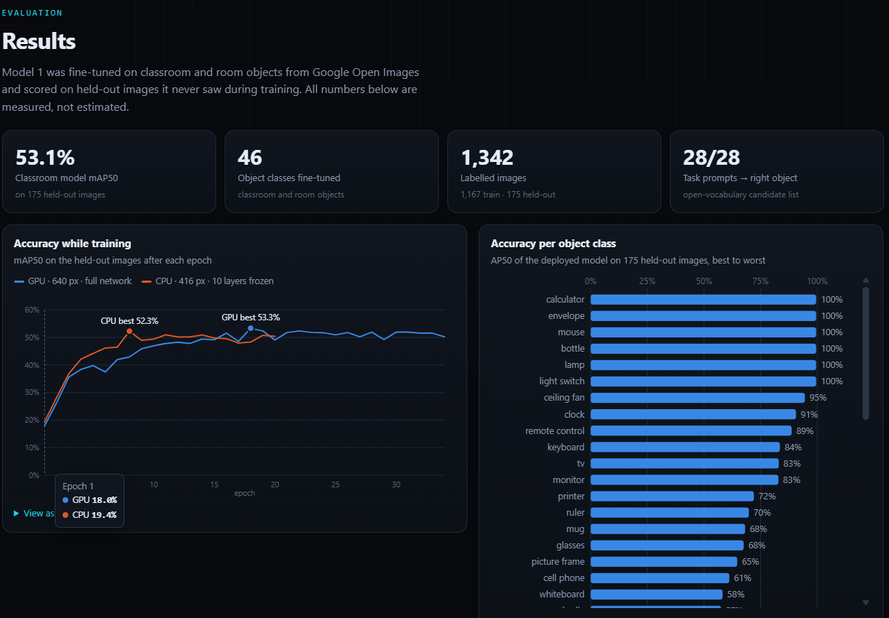
Figure 4.8: Results section of the web dashboard: headline metrics, training curve and per-class accuracy
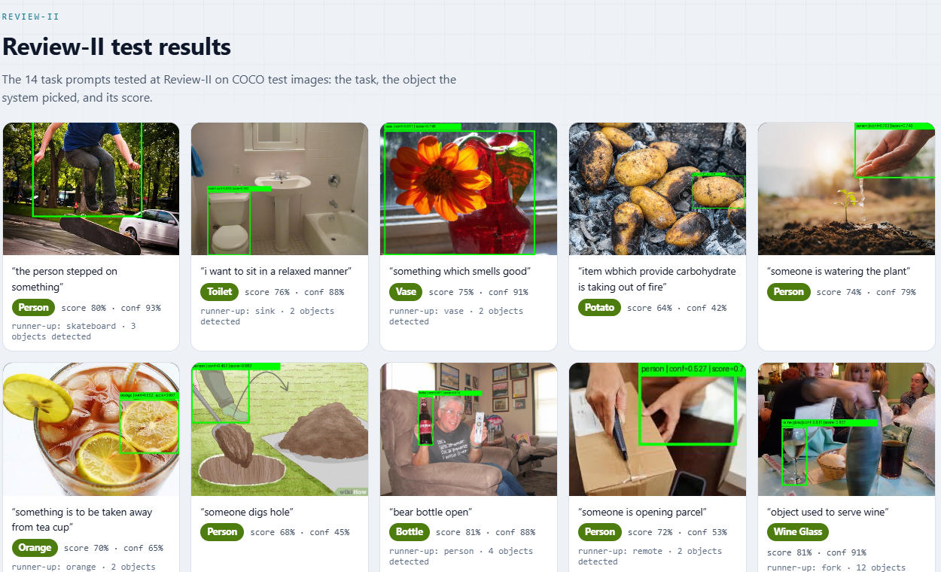
Figure 4.9: Detector comparison table and Review-II result gallery in the dashboard (light theme)

4.8 Discussion
- The image crop is the most informative signal. Label similarity cannot distinguish two candidates of the same class and favours generic words; detector confidence systematically favours people. Making the crop–task similarity the dominant term removed the person bias.
- Describing objects by their use improves task mapping. Affordance descriptions and hubness correction raised the candidate-list hit rate from 10/14 to 14/14 on the original prompts and generalised to 14 new classroom prompts.
- Open-vocabulary detection extends coverage but costs time. It finds objects outside COCO (headphones, clothes, curtains, a fire extinguisher) and selected the correct object in 10 of 12 real-world requests, but it is about 3.5× slower than the fixed-class detectors and is not suitable for the board.
- CLIP re-labelling helps but can also err. It corrected microphone to headphones, yet turned a correctly boxed ceiling fan into a microphone when the crop showed mainly the round hub; widening crops with some context before re-labelling is a simple next step.
- Fine-tuning gives a deployable 46-class model with 53.1% mAP50. It is strong on distinctive objects and weak on large or ambiguous ones, and performs worse on webcam frames than on Open Images photos (headphones were detected with only 0.017 confidence in one webcam frame), indicating a domain gap.
- Action-style prompts remain hard. Tasks that describe a person doing something (“someone digs hole”) lead to the person being selected, because the object needed for the action (a shovel) is not in the detector’s vocabulary or not visible.
CHAPTER 5

Conclusion and Future Work

5.1 Conclusion
This project developed a task-aware object identification system for assistive robotics that turns a natural-language request into a single robot-ready target. A detector (Model 1) proposes objects and a CLIP-based ranking model (Model 2) scores each one against the task using its image crop, its label and the detector confidence. The complete Python pipeline was executed on the PYNQ-Z2 board’s ARM processor, and a hardware–software co-design maps the detector to the board’s programmable logic.
After Review-II the pipeline was substantially improved. Scoring now uses the user’s actual task rather than the nearest of 14 fixed phrases, the image-crop similarity dominates the fusion and a person penalty removes the bias towards people. An open-vocabulary detector with a 220-object affordance vocabulary, hubness correction and CLIP re-labelling finds everyday objects outside COCO; the task-to-object mapping reaches 28/28 on the evaluated prompts, and 10 of 12 real-world requests in a hostel room, computer laboratory and classroom selected the correct object. A YOLO11n detector fine-tuned on 1,342 Open Images photos recognises 46 classroom and room objects with 53.1% mAP50 and is suitable for board deployment. A web dashboard demonstrates the system, saves every result and shows the board’s connection state.

5.2 Limitations
- The FPGA (PL) detector has not yet been benchmarked for frame rate, power or resource utilisation; the measured pipeline runs in software.
- The open-vocabulary detector runs only on the host computer.
- The fine-tuned detector has a domain gap between Open Images photos and webcam frames, and several classes have very few validation images.
- Prompts describing a person performing an action are not handled well, and the evaluation prompts were written by the team rather than drawn from an independent benchmark.

5.3 Future Work
- Export the fine-tuned detector to ONNX/INT8, deploy it as the PL overlay and report FPS, latency, power and LUT/DSP/BRAM utilisation.
- Stream the camera through AXI VDMA with an HDMI overlay for live on-board operation.
- Run inference requests from the dashboard on the board (“board mode”) and display on-board timing.
- Collect and label 100–200 images from the target classroom and rooms to close the domain gap, and re-train on the GPU.
- Build a household and classroom task test set (COCO-Tasks style) and report top-1 selection accuracy.
- Add a confidence gate before the robot acts, and send the selected bounding-box centre to a robot controller for a navigation or grasping demonstration.
- Add speech input so users can speak their request directly.

Appendix
Appendix 1: Setup and Usage
Environment. Create a Python 3.11 virtual environment in a short path (for example C:\Users\<user>\venvs\pynq) — the project folder path is longer than the Windows 260-character limit allows for package installation — and install requirements.txt. For GPU training a separate environment with the CUDA 12.1 build of PyTorch 2.3.1 is used.
Run the web dashboard:
C:\Users\<user>\venvs\pynq\Scripts\python.exe PJT1\web\server.py
# or double-click run_dashboard.bat, then open http://localhost:8000
Run the desktop camera interface with the open-vocabulary detector:
cd PJT1\YOLO_custom
python orchestrator.py --camera --detector world
Run one image from the command line:
python run_model2_with_image_output.py --image photo.jpg \
--task "something to drink from" --detector classroom
Rebuild the classroom dataset and re-train:
cd PJT1\finetune
python prepare_openimages.py --per-class 40
python train_classroom.py --device 0 --imgsz 640 --batch 6 \
--freeze 0 --lr0 0.01 --patience 20 --name classroom_gpu
Table A.1: Main source files
File | Purpose
PJT1/YOLO_custom/yolo_inference.py | Model 1: YOLO11n, YOLO-World and fine-tuned detectors
PJT1/YOLO_custom/open_vocab.py | 220-object affordance vocabulary, hubness correction, class-list builder
PJT1/YOLO_custom/run_model2_with_image_output.py | Model 2: CLIP re-labelling, score fusion, selection, annotated output
PJT1/Classifier_Custom/task_aware_selector.py | CLIP loading, text encoding, detection filtering
PJT1/YOLO_custom/orchestrator.py | End-to-end pipeline, OpenCV camera UI with tracking
PJT1/YOLO_custom/putty_bridge.py | PuTTY / TCP terminal interface
PJT1/web/server.py, static/index.html | Web dashboard, result saving, board detection
PJT1/finetune/prepare_openimages.py, train_classroom.py | Classroom dataset builder and fine-tuning

Appendix 2: Sample Output (result.json)
Abridged result.json written by the dashboard for the task “headphones” (open-vocabulary detector). Only the first two ranked candidates are shown.
{
"task": "headphones",
"detector": "world",
"vocabulary": ["headphones", "earphones", "earbuds", "microphone",
"sunglasses", "speaker", "helmet", "glasses", "cell phone"],
"selected": {
"class_name": "headphones",
"confidence": 0.2001,
"bbox": [644.92, 255.99, 774.82, 469.91],
"score": 0.5257,
"cos_sim": 0.9537,
"image_cos_sim": 0.2978
},
"ranked": [
{ "class_name": "headphones", "detector_label": "headphones",
"clip_label_prob": 0.581, "confidence": 0.2001, "score": 0.5257 },
{ "class_name": "headphones", "detector_label": "sunglasses",
"clip_label_prob": 0.7229, "confidence": 0.1446, "score": 0.2565 }
],
"elapsed_ms": 3611,
"saved_at": "2026-10-16 14:52:38"
}
Appendix 3: Key Code Listings
Score fusion in Model 2 (run_model2_with_image_output.py, abridged):
crop_probs = torch.softmax(100.0 * torch.tensor(crop_cos_sims), dim=0)
label_probs = torch.softmax(100.0 * cos_sim, dim=0)
person_requested = mentions_person(task_text)
for idx, det in enumerate(filtered):
fused = (0.55 * float(crop_probs[idx])
+ 0.25 * float(label_probs[idx])
+ 0.20 * float(det["confidence"]))
if det["class_name"] == "person" and not person_requested:
fused *= 0.5
Task-to-object ranking with hubness correction (open_vocab.py, abridged):
texts = [f"{obj}, used to {OBJECT_USES[obj]}" for obj in OBJECT_VOCAB]
embs = F.normalize(clip_model.encode_text(tokenizer(texts)), dim=-1)
hub_bias = ((embs @ embs.T).sum(dim=1) - 1.0) / (len(OBJECT_VOCAB) - 1)
task_emb = F.normalize(clip_model.encode_text(tokenizer([task_text])), dim=-1)
sims = (task_emb @ embs.T).squeeze(0) - hub_bias
ranked = sorted(zip(OBJECT_VOCAB, sims.tolist()), key=lambda x: x[1], reverse=True)
CLIP re-labelling of an open-vocabulary box (run_model2_with_image_output.py, abridged):
text = clip_model.encode_text(tokenizer([f"a photo of a {c}" for c in vocabulary]))
emb = clip_model.encode_image(preprocess(crop).unsqueeze(0))
probs = torch.softmax(100.0 * (emb @ text.T).squeeze(0), dim=0)
det["class_name"] = vocabulary[int(probs.argmax())]

Bibliography
[1] J. Redmon, S. Divvala, R. Girshick, and A. Farhadi, “You Only Look Once: Unified, Real-Time Object Detection,” in Proc. IEEE CVPR, 2016, pp. 779–788.
[2] J. Redmon and A. Farhadi, “YOLO9000: Better, Faster, Stronger,” in Proc. IEEE CVPR, 2017, pp. 7263–7271.
[3] Z. Yan, B. Zhang, and D. Wang, “An FPGA-Based YOLOv5 Accelerator for Real-Time Industrial Vision Applications,” Micromachines, vol. 15, no. 9, Art. no. 1164, 2024, doi: 10.3390/mi15091164.
[4] E. Emmanuel, F. Lacy, and Y. Ismail, “Optimizing Resource Utilization and Power Efficiency in FPGA-Accelerated YOLOv8 Object Detection Using Vivado HLS,” in Proc. 2nd Int. Conf. AIBThings, 2024, pp. 1–4, doi: 10.1109/AIBThings.2024.10863546.
[5] X. Sha, M. Yanagisawa, and Y. Shi, “An FPGA-Based YOLOv6 Accelerator for High-Throughput and Energy-Efficient Object Detection,” IEICE Trans. Fundamentals, vol. E108-A, no. 3, pp. 473–481, 2025.
[6] Z. Zhang, M. A. P. Mahmud, and A. Z. Kouzani, “Resource-Constrained FPGA Implementation of YOLOv2,” Neural Comput. Appl., vol. 34, no. 19, pp. 16989–17006, 2022.
[7] Y. Umuroglu et al., “FINN: A Framework for Fast, Scalable Binarized Neural Network Inference,” in Proc. ACM/SIGDA Int. Symp. FPGA, 2017, pp. 65–74.
[8] A. Radford et al., “Learning Transferable Visual Models From Natural Language Supervision,” in Proc. ICML, PMLR vol. 139, 2021, pp. 8748–8763.
[9] J. Sawatzky, Y. Souri, C. Grund, and J. Gall, “What Object Should I Use? – Task Driven Object Detection,” in Proc. IEEE/CVF CVPR, 2019, pp. 7605–7614.
[10] P. Li et al., “TOIST: Task Oriented Instance Segmentation Transformer with Noun-Pronoun Distillation,” in Proc. NeurIPS, 2022.
[11] J. Tang, G. Zheng, J. Yu, and S. Yang, “CoTDet: Affordance Knowledge Prompting for Task Driven Object Detection,” in Proc. IEEE/CVF ICCV, 2023.
[12] M. Minderer et al., “Simple Open-Vocabulary Object Detection with Vision Transformers,” in Proc. ECCV, 2022.
[13] T. Cheng, L. Song, Y. Ge, W. Liu, X. Wang, and Y. Shan, “YOLO-World: Real-Time Open-Vocabulary Object Detection,” in Proc. IEEE/CVF CVPR, 2024.
[14] M. Shridhar, L. Manuelli, and D. Fox, “CLIPort: What and Where Pathways for Robotic Manipulation,” in Proc. CoRL, PMLR vol. 164, 2021.
[15] M. Ahn et al., “Do As I Can, Not As I Say: Grounding Language in Robotic Affordances,” in Proc. CoRL, PMLR vol. 205, 2022.
[16] G. Jocher and J. Qiu, “Ultralytics YOLO11,” version 11.0.0, 2024. [Online]. Available: https://github.com/ultralytics/ultralytics
[17] A. Kuznetsova et al., “The Open Images Dataset V4: Unified Image Classification, Object Detection, and Visual Relationship Detection at Scale,” Int. J. Comput. Vis., vol. 128, pp. 1956–1981, 2020.
[18] T.-Y. Lin et al., “Microsoft COCO: Common Objects in Context,” in Proc. ECCV, 2014, pp. 740–755.
[19] M. Radovanović, A. Nanopoulos, and M. Ivanović, “Hubs in Space: Popular Nearest Neighbors in High-Dimensional Data,” J. Mach. Learn. Res., vol. 11, pp. 2487–2531, 2010.
[20] AMD/Xilinx, “PYNQ: Python Productivity for Zynq.” [Online]. Available: http://www.pynq.io
[21] TUL Corporation, “PYNQ-Z2 Reference Manual.” [Online]. Available: https://www.tulembedded.com
[22] G. Ilharco et al., “OpenCLIP,” Zenodo, 2021, doi: 10.5281/zenodo.5143773.

Biodata
Name: Shubh Gupta | 
Reg. No.: 23BLC1322
Mobile No.: 8052933770
E-mail: shubh.gupta2023@vitstudent.ac.in
Permanent Address: 2/31 Hata Mangal Khan, Ghumna Bazaar, Farrukhabad – 209625

Name: Aarav Sharma | 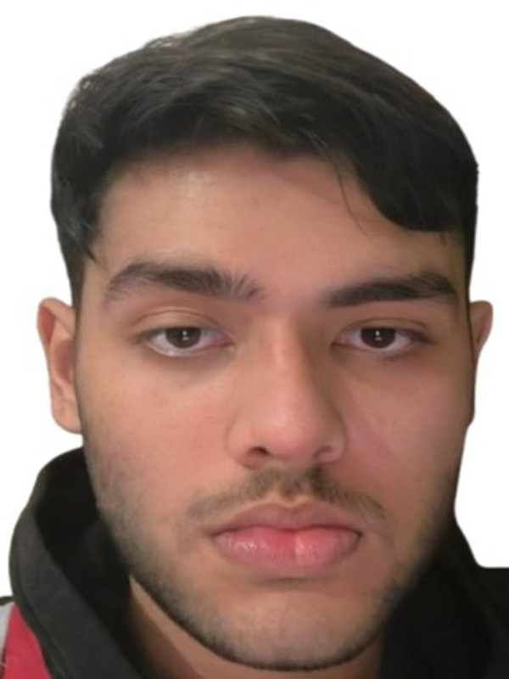
Reg. No.: 23BLC1300
Mobile No.: +91 90123 13969
E-mail: aarav.sharma2023@vitstudent.ac.in
Permanent Address: 792/Sector 11, Vasundhara, Ghaziabad, Uttar Pradesh

Name: Ankush Kumar Jaiswal | 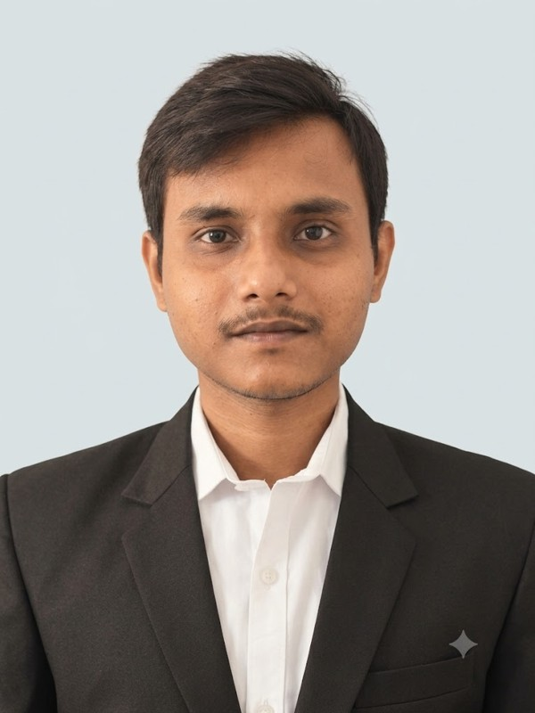
Reg. No.: 23BLC1179
Mobile No.: 8577833787
E-mail: ankushkumar.jaiswal2023@vitstudent.ac.in
Permanent Address: Ram Sevak Bhawan, D11/2, Karaundhi Crossing

